## In the partial fulfillment of

**Master of Science – MSc IT Sem 5**



**L.J School of Computer Applications, LJKU**

Elite Footwear Virtual Store

### Developed by : Aesha, Khushi, Darsh Guided by: Virendra Ingle

**Name:** **Khushi Chauhan**

**Enrollment: 21004500210243**

**Name: Aesha Bhavsar**

**Enrollment: 21004500210190**

**Name: Darsh Patel**

**Enrollment: 21004500210206**

### L.J. INSTITUTE OF COMPUTER APPLICATIONS

Near Nagdev Kalyan Mandir, Near Sanand Cross Roads,

Sarkhej-Gandhinagar Highway Ahmedabad – 382210

Ph. No. : 9099063417



#### CERTIFICATE

**Enrollment No**:21004500210243 **Seat No:** _

This is to certify that **Khushi Chauhan** of Master of Science (MScIT), Semester V,

Roll No  **57** has satisfactorily completed his/her Project titled **Elite Footwear Virtual Store** in

**Django** under the supervision of an internal guide.

**Internal Guide: HOD:**

Prof. Virendra Ingle Dr. Jignesh Doshi

**Date of Submission:**

**30/11/23**

### L.J. INSTITUTE OF COMPUTER APPLICATIONS

Near Nagdev Kalyan Mandir, Near Sanand Cross Roads,

Sarkhej-Gandhinagar Highway Ahmedabad – 382210

Ph. No. : 9099063417



#### CERTIFICATE

**Enrollment No**:21004500210190 **Seat No:** _

This is to certify that **Aesha Bhavsar** of Master of Science (MScIT), Semester V,

Roll No **04** has satisfactorily completed his/her Project titled **Elite Footwear Virtual Store** in

**Django** under the supervision of an internal guide.

**Internal Guide: HOD:**

Prof. Virendra Ingle Dr. Jignesh Doshi

**Date of Submission:**

**30/11/23**

### L.J. INSTITUTE OF COMPUTER APPLICATIONS

Near Nagdev Kalyan Mandir, Near Sanand Cross Roads,

Sarkhej-Gandhinagar Highway Ahmedabad – 382210

Ph. No. : 9099063417



#### CERTIFICATE

**Enrollment No**:21004500210206 **Seat No:** _

This is to certify that **Darsh Patel** of Master of Science (MScIT), Semester V,

Roll No **21** has satisfactorily completed his/her Project titled **Elite Footwear Virtual Store** in

**Django** under the supervision of an internal guide.

**Internal Guide: HOD:**

Prof. Virendra Ingle Dr. Jignesh Doshi

**Date of Submission:**

**30/11/23**

|  |  |  |
| --- | --- | --- |
| **Sr.**  **No.** | **TABLE OF CONTENTS** | **Page No.** |
| **1.** | **INTRODUCTION** |  |
|  | 1.1 Existing System |  |
|  | 1.2 Need for the New System |  |
|  | 1.3 Objective of the New System |  |
|  | 1.4 Problem Definition |  |
|  | 1.5 Core Components |  |
|  | 1.6 Project Profile |  |
|  | 1.7 Assumptions and Constraints |  |
|  | 1.8 Advantages and Limitations of the Proposed System |  |
| **2.** | **REQUIREMENT DETERMINATION & ANALYSIS** |  |
|  | 2.1 Requirement Determination |  |
|  | 2.2 Targeted Users |  |
| **3.** | **SYSTEM DESIGN** |  |
|  | 3.1 Use Case Diagram |  |
|  | 3.2 Class Diagram |  |
|  | 3.3 Interaction Diagram |  |
|  | 3.4 Activity Diagram |  |
|  | 3.5 Data Dictionary |  |
| **4.** | **DEVELOPMENT** |  |
|  | 4.1 Coding Standard |  |
|  | 4.2 Screenshots |  |
| **5.** | **AGILE DOCUMENTATION** |  |
|  | 5.1 Agile Project Charter |  |
|  | 5.2 Agile Roadmap / Schedule |  |
|  | 5.3 Agile Project Plan |  |
|  | 5.4 Agile User Story (Minimum 3 Tasks) |  |
|  | 5.5 Agile Release Plan |  |
|  | 5.6 Agile Sprint Backlog |  |
|  | 5.7Earned-value and Burn Chart |  |
|  | 5.8Earned-value and Burn Chart |  |
| **6.** | **PROPOSED ENHANCEMENTS** |  |
| **7.** | **CONCLUSION** |  |
| **8.** | **BIBLIOGRAPHY** |  |

**1. Introduction**

The Online Footwear Shopping System is a web-based application that allows users to browse and purchase footwear products online. The system provides an intuitive interface for customers to explore a wide range of shoes, make secure online payments, and manage their orders. The project also includes an administrator control panel for efficient management of products, orders, and customer data.

**1.1 Existing System**

At the outset of this project, we examine the limitations of the existing footwear shopping system. The conventional method of purchasing footwear typically involves physically visiting brick-and-mortar stores. This approach is often time-consuming, offers limited choices, and lacks the convenience that modern consumers seek in their shopping experiences.

**1.2 Need for the New System**

The need for a new system arises from the changing landscape of consumer preferences and the growing demand for online shopping. Customers increasingly expect a broader range of choices, a convenient shopping experience, and the ability to make informed decisions before purchasing footwear.

**1.3 Objective of the New System**

The primary objective of the new Online Footwear Shopping System is to bridge the gap between traditional shoe shopping and modern e-commerce. By creating an intuitive online platform, we aim to provide customers with a seamless and convenient means of exploring a wide range of footwear products from the comfort of their own homes.

**1.4 Problem Definition**

The central issue addressed by this project is the inconvenience and limited choices associated with traditional footwear shopping methods. We seek to rectify this problem by developing an online solution that offers an extensive catalog of footwear products and a user-friendly shopping experience.

**1.5 Core Components**

**Customer:**

* User registration and authentication
* A comprehensive product catalog
* A shopping cart system
* Secure checkout
* User profile management

**Delivery Employee:**

* User registration and authentication
* User profile management
* Delivery dashboard
* Order Confirmation
* Order detail
* Pending delivery
* Completed delivery
* Canceled delivery
* Delivery history
* Tracking location

**Admin:**

* Login/ Registration
* User Management
* User Verification
* System Reports
* User Profile Management
* Delivery employee management

**1.6 Project Profile**

|  |  |
| --- | --- |
| **Front End** | HTML, CSS, Java Script, Bootstrap |
| **Back End** | Django(Python Web Framework) |
| **Database** | My SQL |
| **Diagram-builder** | Draw.io |

**1.7 Assumptions and Constraints**

We acknowledge that certain assumptions and constraints may affect the project's execution. These include factors such as budgetary restrictions, time constraints, and resource availability. Understanding and addressing these assumptions and constraints will be crucial in managing project expectations and outcomes.

**1.8 Advantages and Limitations of the Proposed System**

**Advantages:**

* **Convenience:** Customers can shop for footwear from anywhere with an internet connection.
* **Diverse Selection:** A wide variety of footwear options of styles.
* **Personalization:** Customers can create profiles and receive tailored recommendations.
* **Efficiency:** Streamlined checkout and order management for administrators.

**Limitations:**

* **Internet Access:** Requires internet access, potentially excluding some customers.
* **Security Concerns:** Risks associated with data security.
* **Returns and Sizing:** Challenges related to returns and sizing accuracy in online shopping.

**2. Requirement Determination & Analysis**

**2.1 Requirement Determination**

This section focuses on identifying the system's functional and non-functional requirements.

**Functional Requirements**

Functional requirements describe what the system should do. For the Online Footwear Shopping System, this includes features like user registration, product catalog, shopping cart, checkout, user profiles, and admin controls.

**Non-Functional Requirements**

Non-functional requirements define how well the system should perform. Key aspects include security, performance, scalability, usability, compatibility, reliability, data integrity, and compliance with regulations.

**2.2 Targeted Users**

* Customer
* Delivery Employee
* Administrator

**3. System Design**

**3.1 Use Case Diagram**

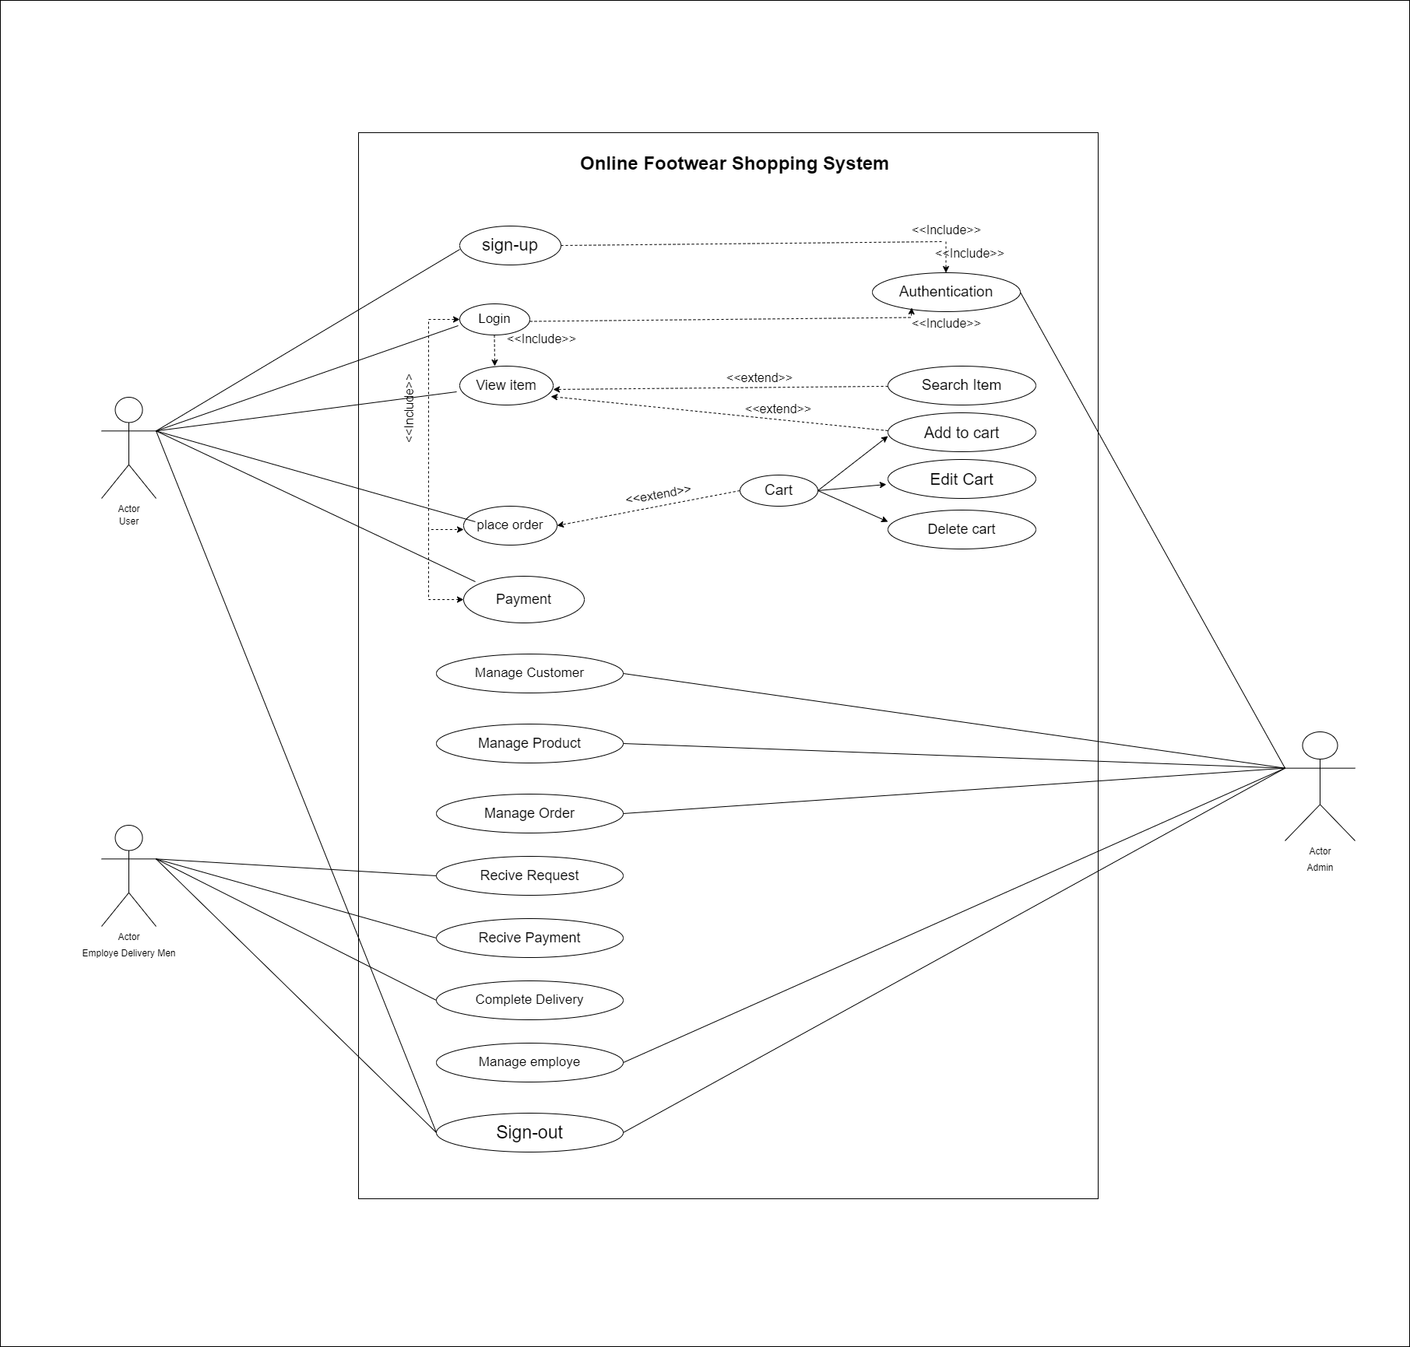

**3.2 Class Diagram**

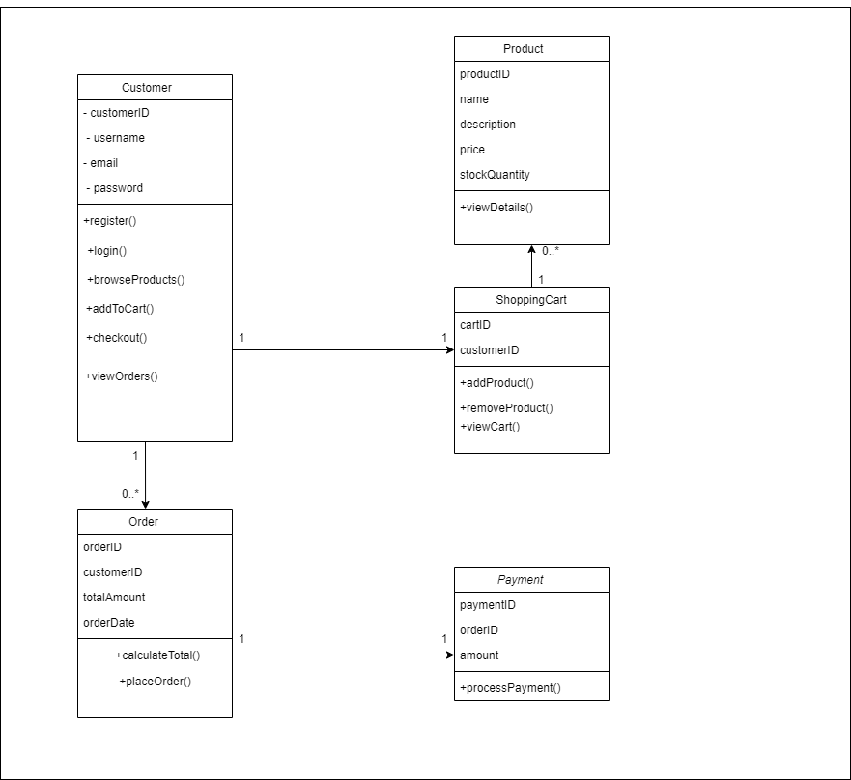

**3.3 Interaction Diagram**

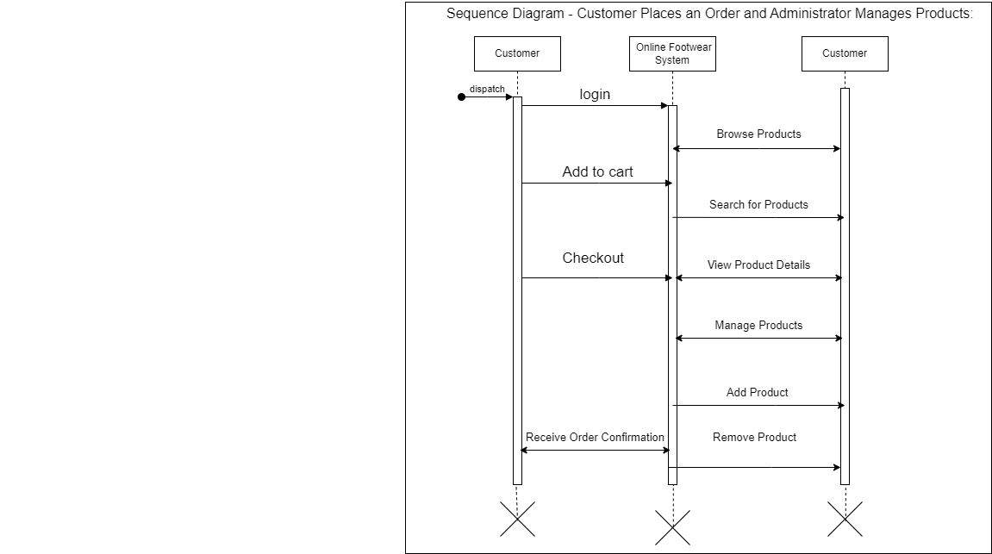

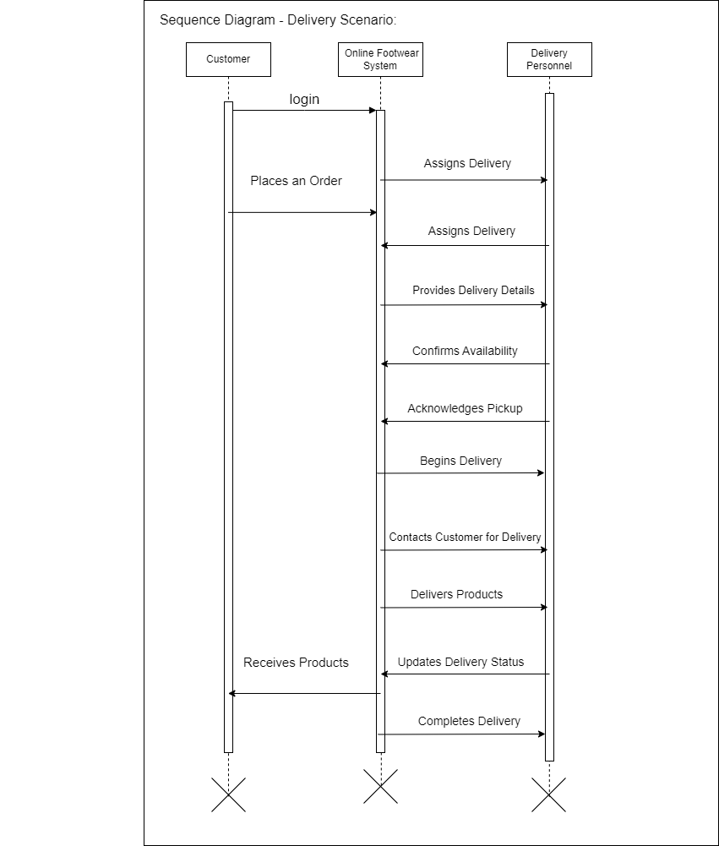

**3.4 Activity Diagram**

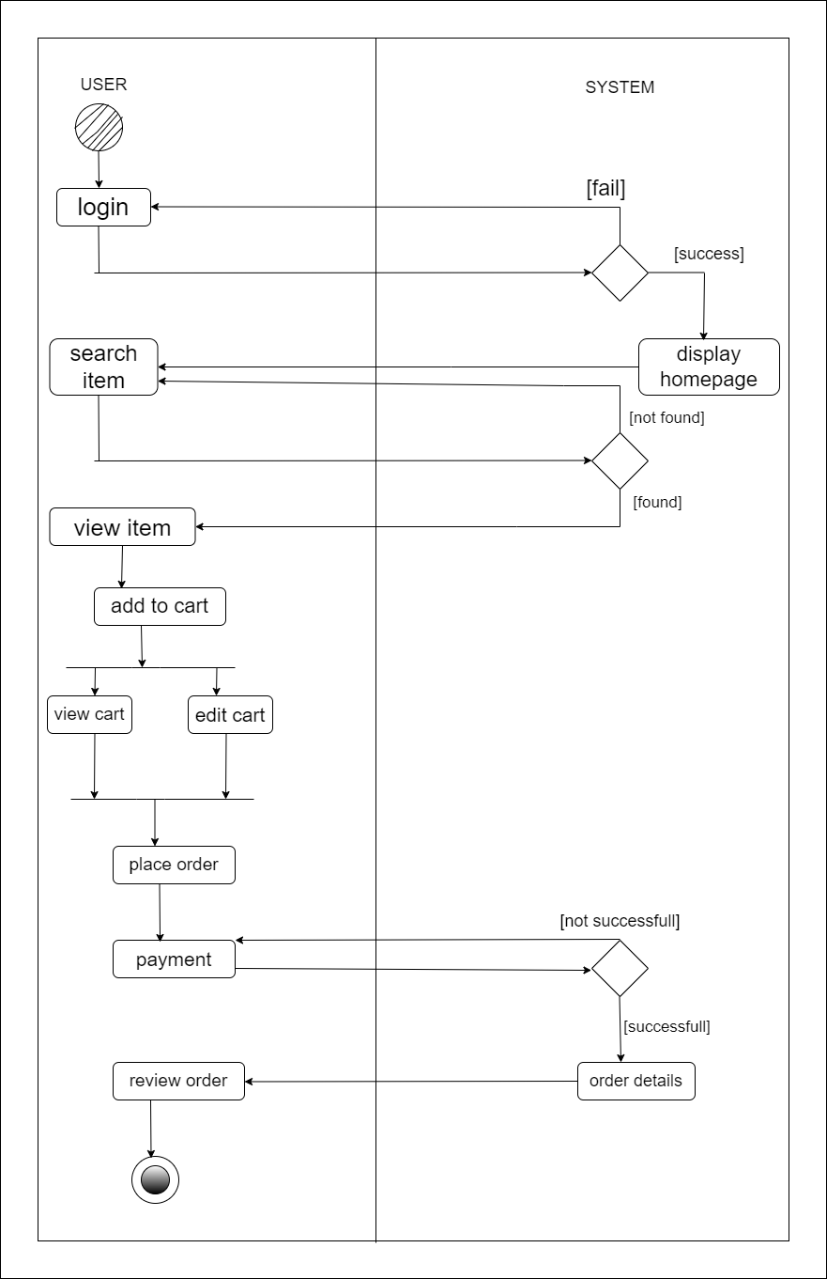

**3.5 Data Dictionary**

**Table Name:** Users

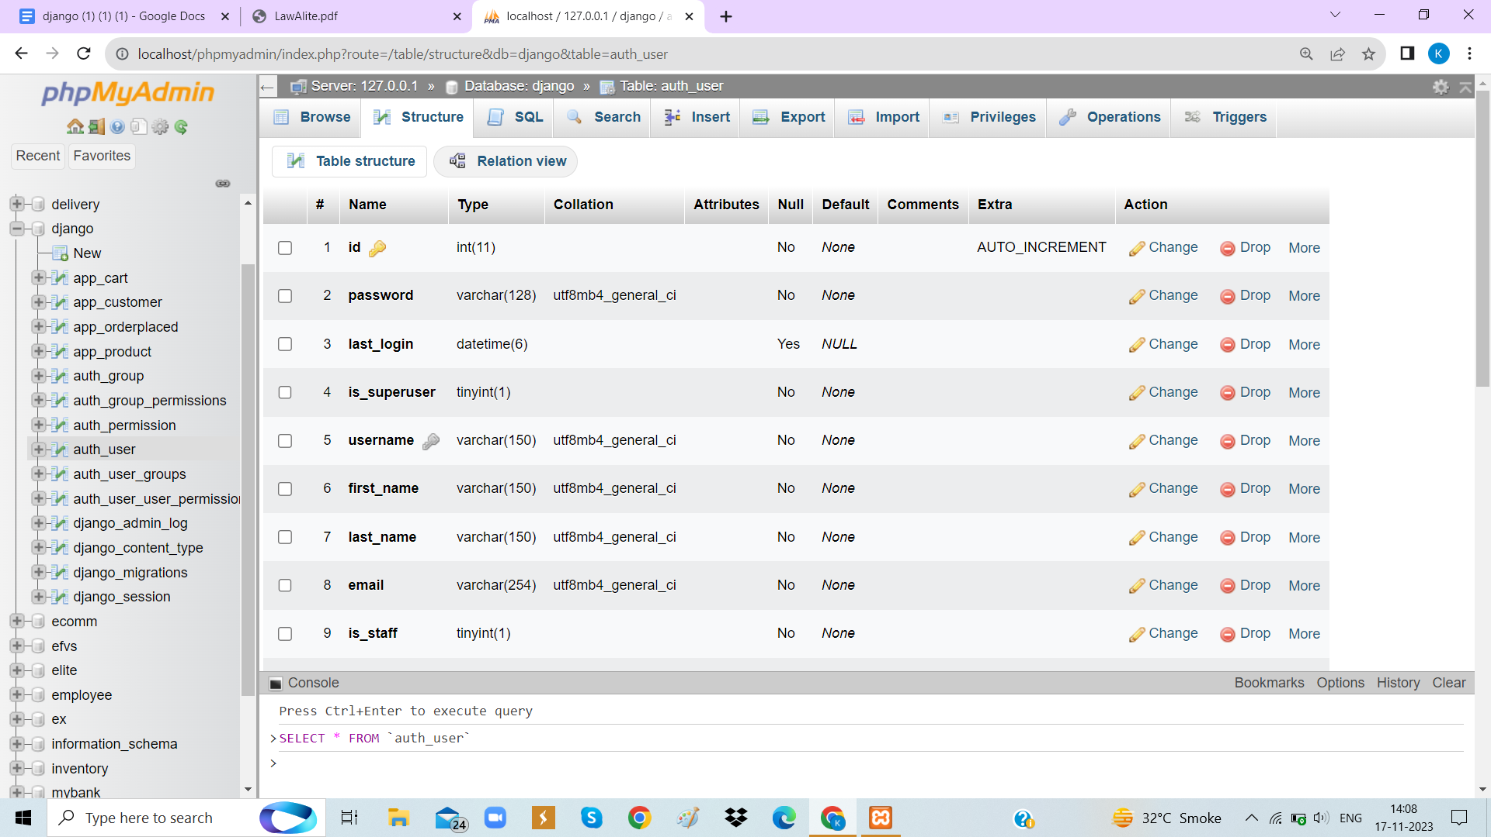

**Table Name:** Product

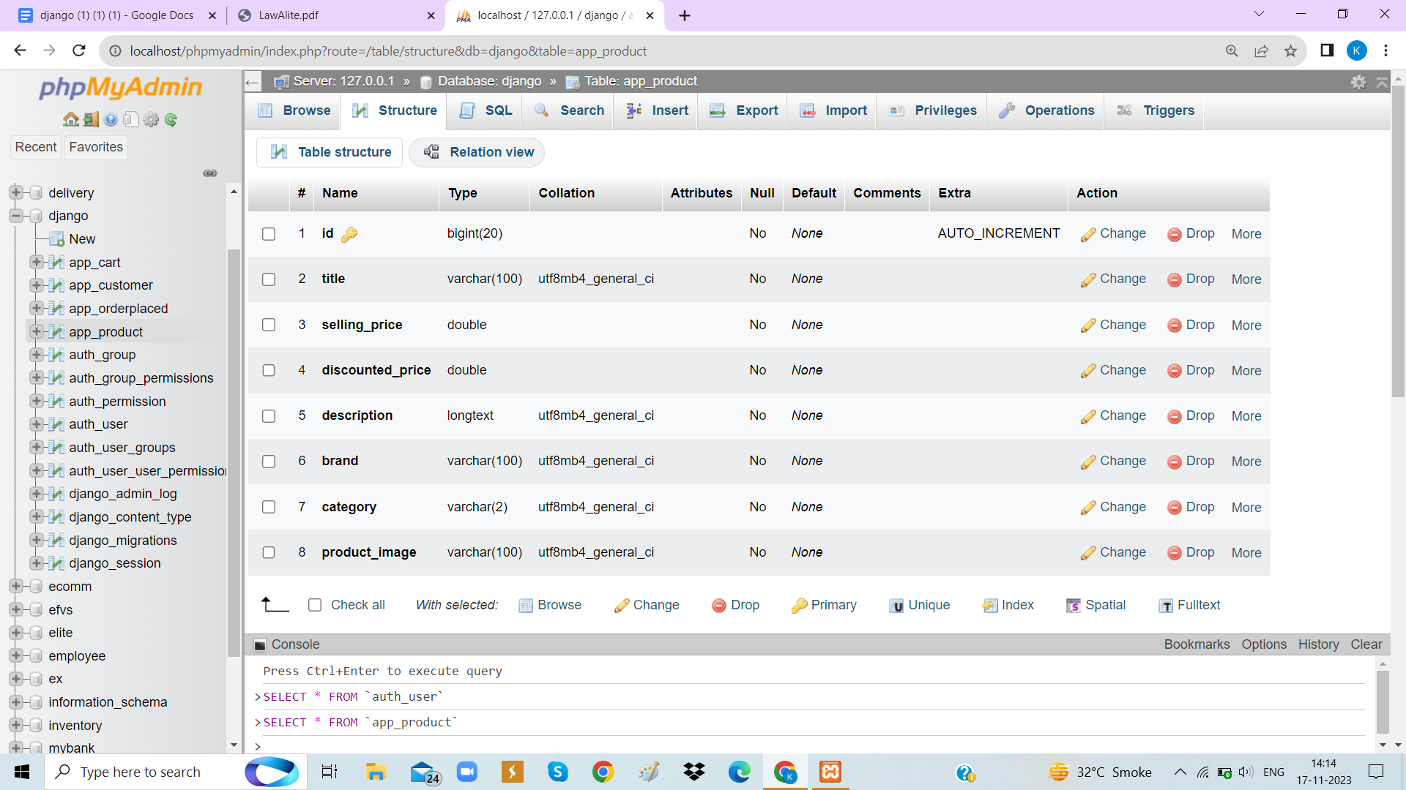

**Table Name:** Orderplaced

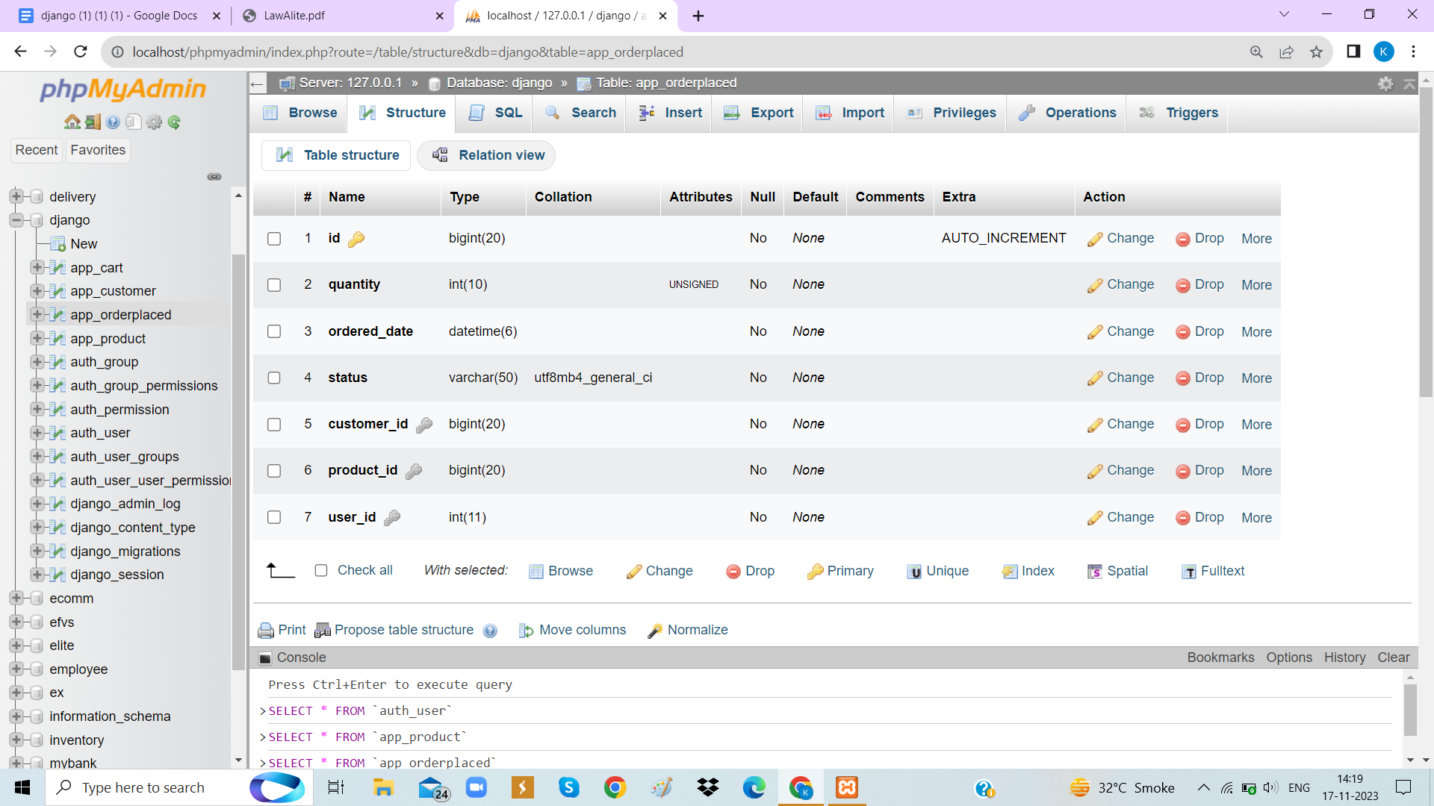

**Table Name:** Cart

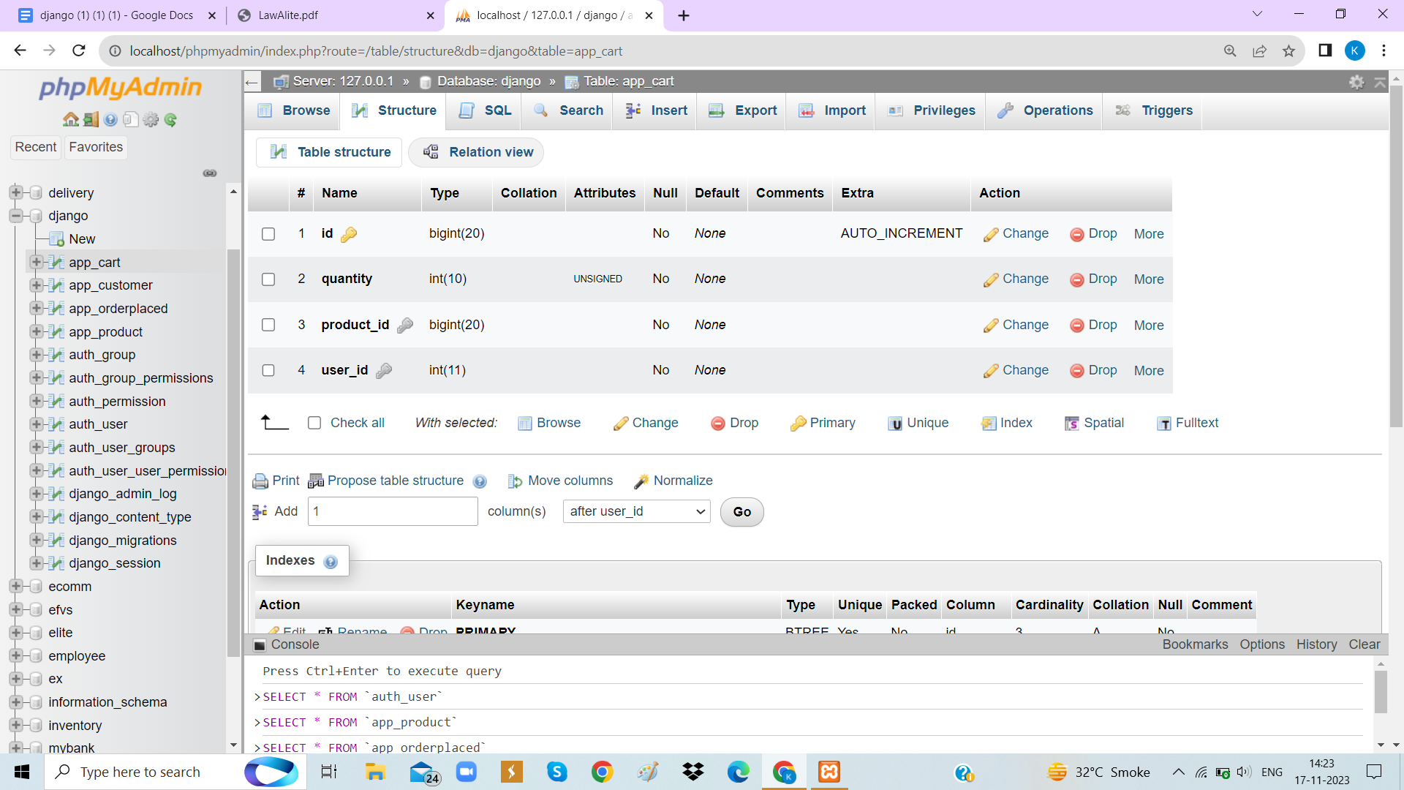

**Table Name:** Customer

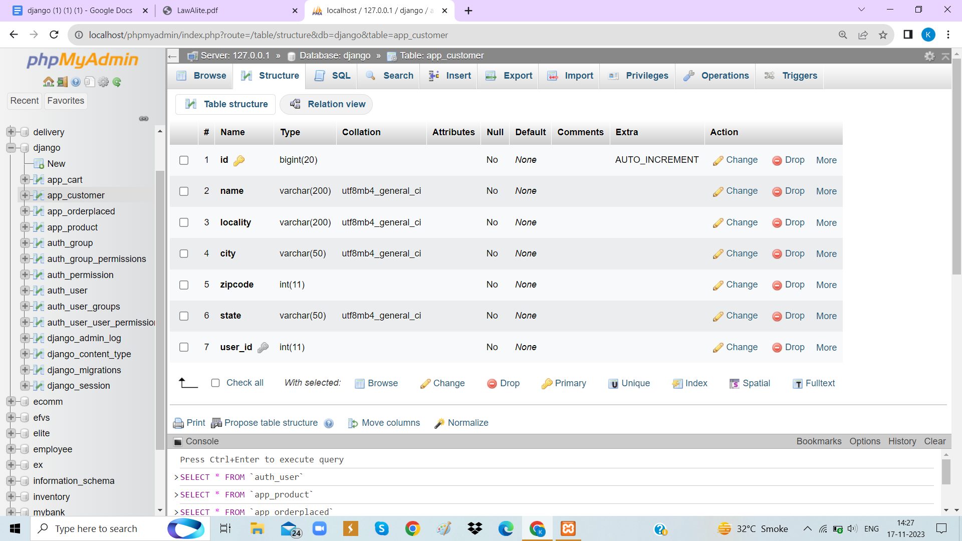

**4.Development**

**4.1 Coding Standard**

Naming conventions make sure programmer know how to

name variable and classes so that they will be consistent and contain

all the right information.

Classes, enums, typedefs, and extensions name should

in UpperCamelCase.

Packages, Libraries, Directories, and source files name should

be in snake_case(lowercase_with_underscores).

Documentation comments with three slashes (///) are used for

documenting the code. Anything you think will stay in the code

forever should use this style of comments.

**4.2 Screenshots**

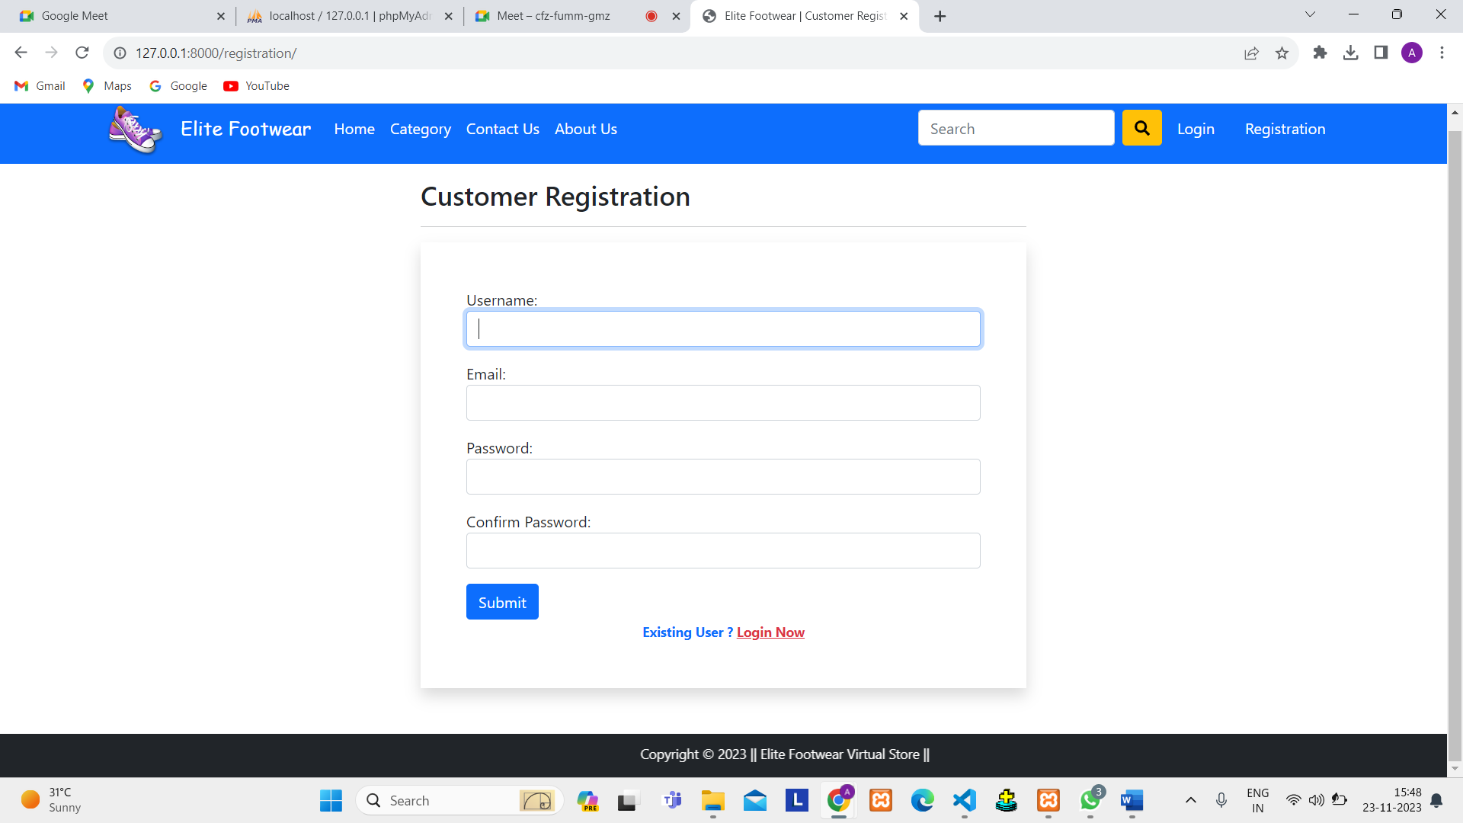

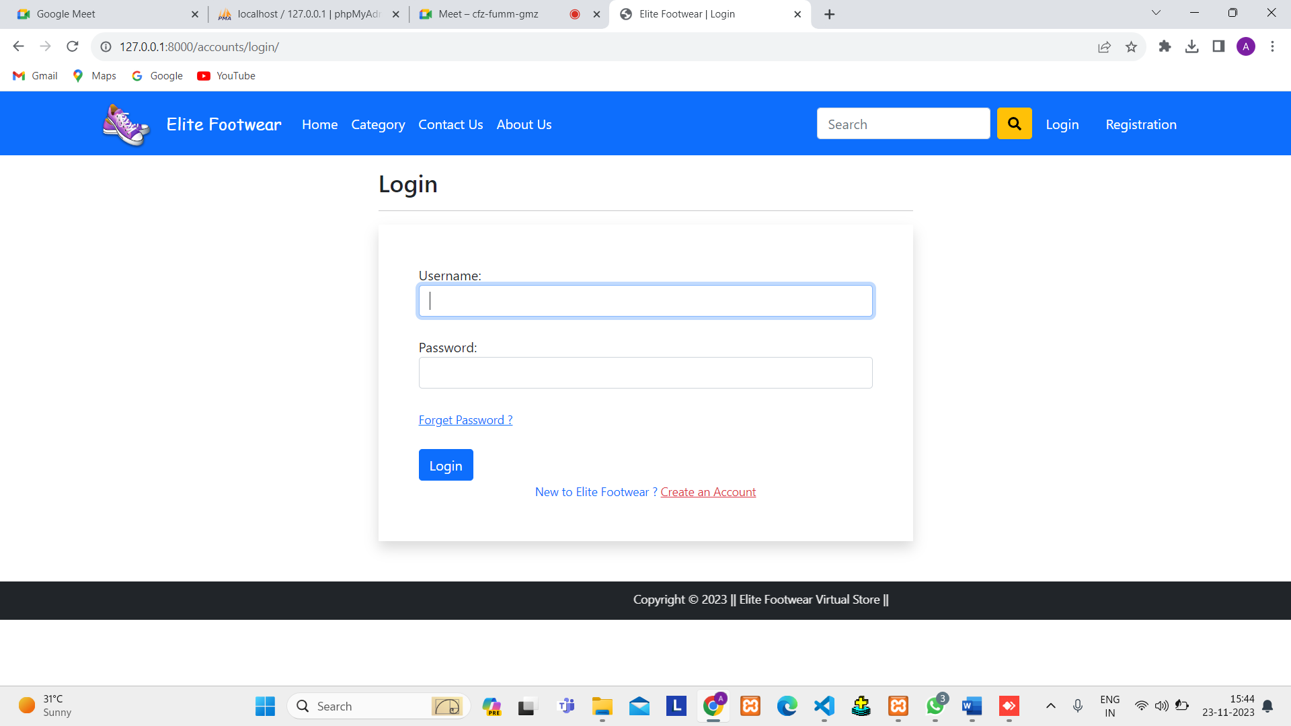

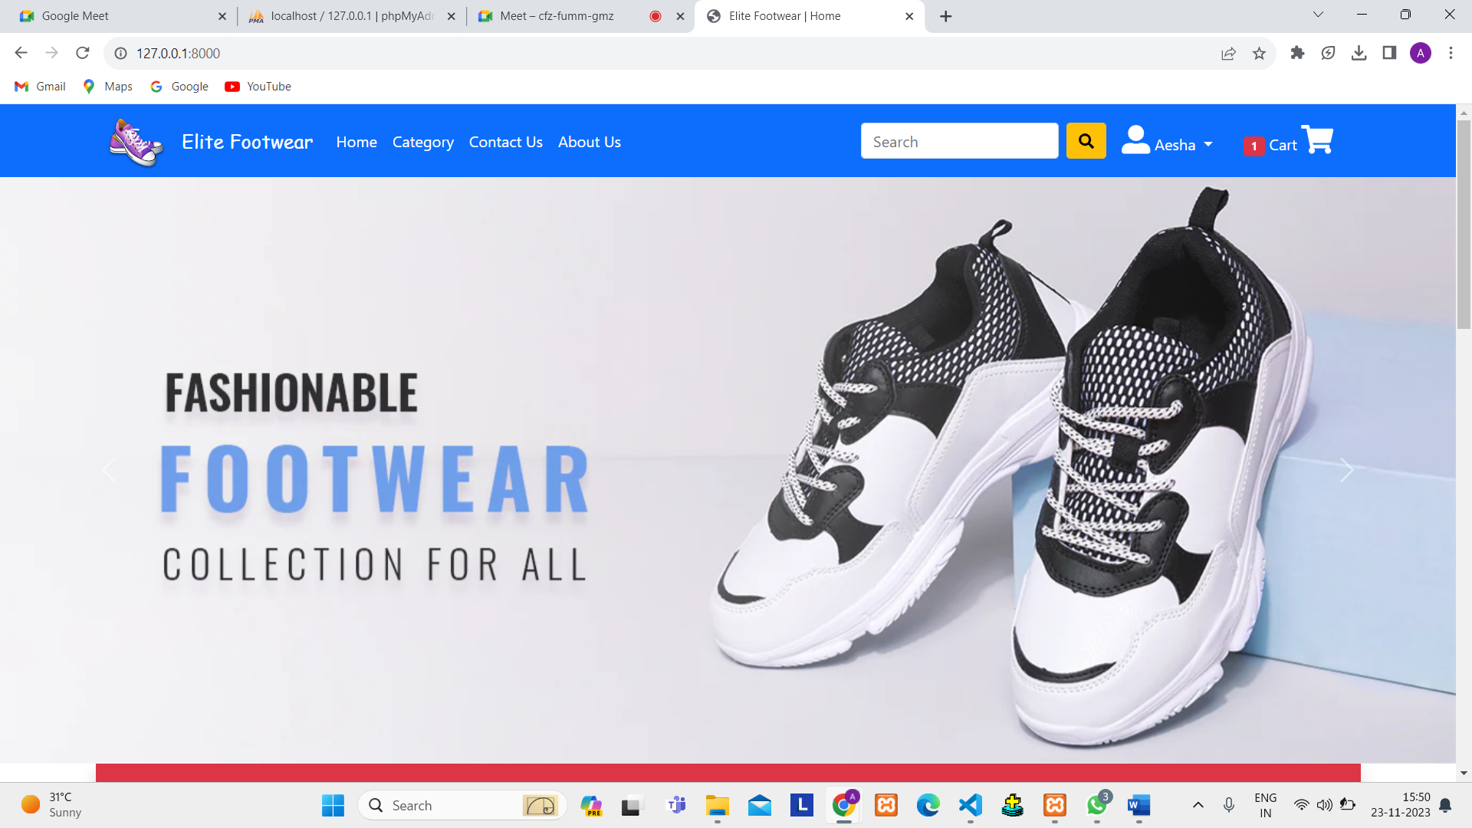

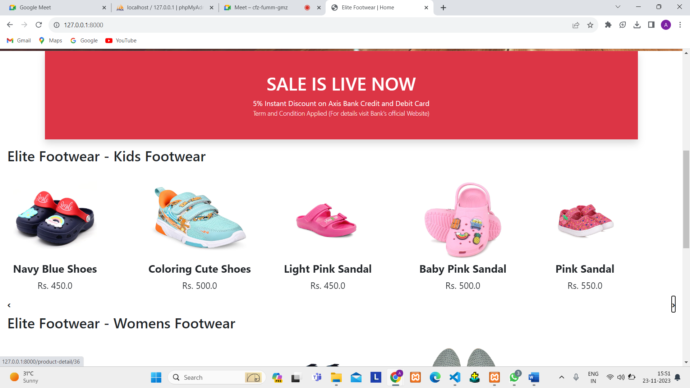

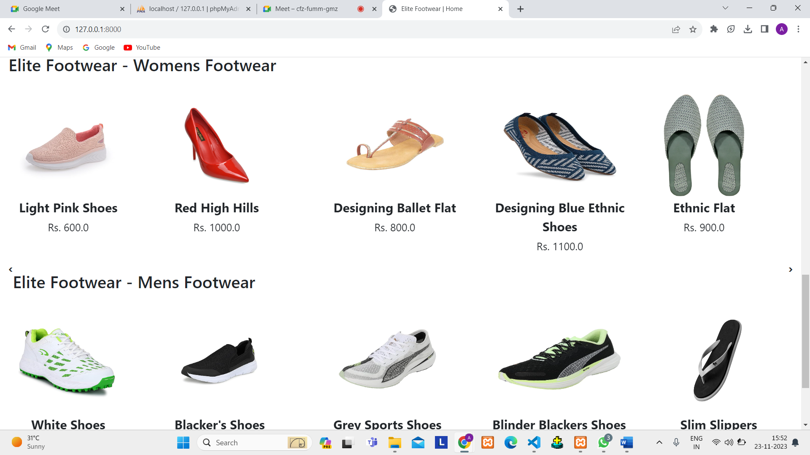

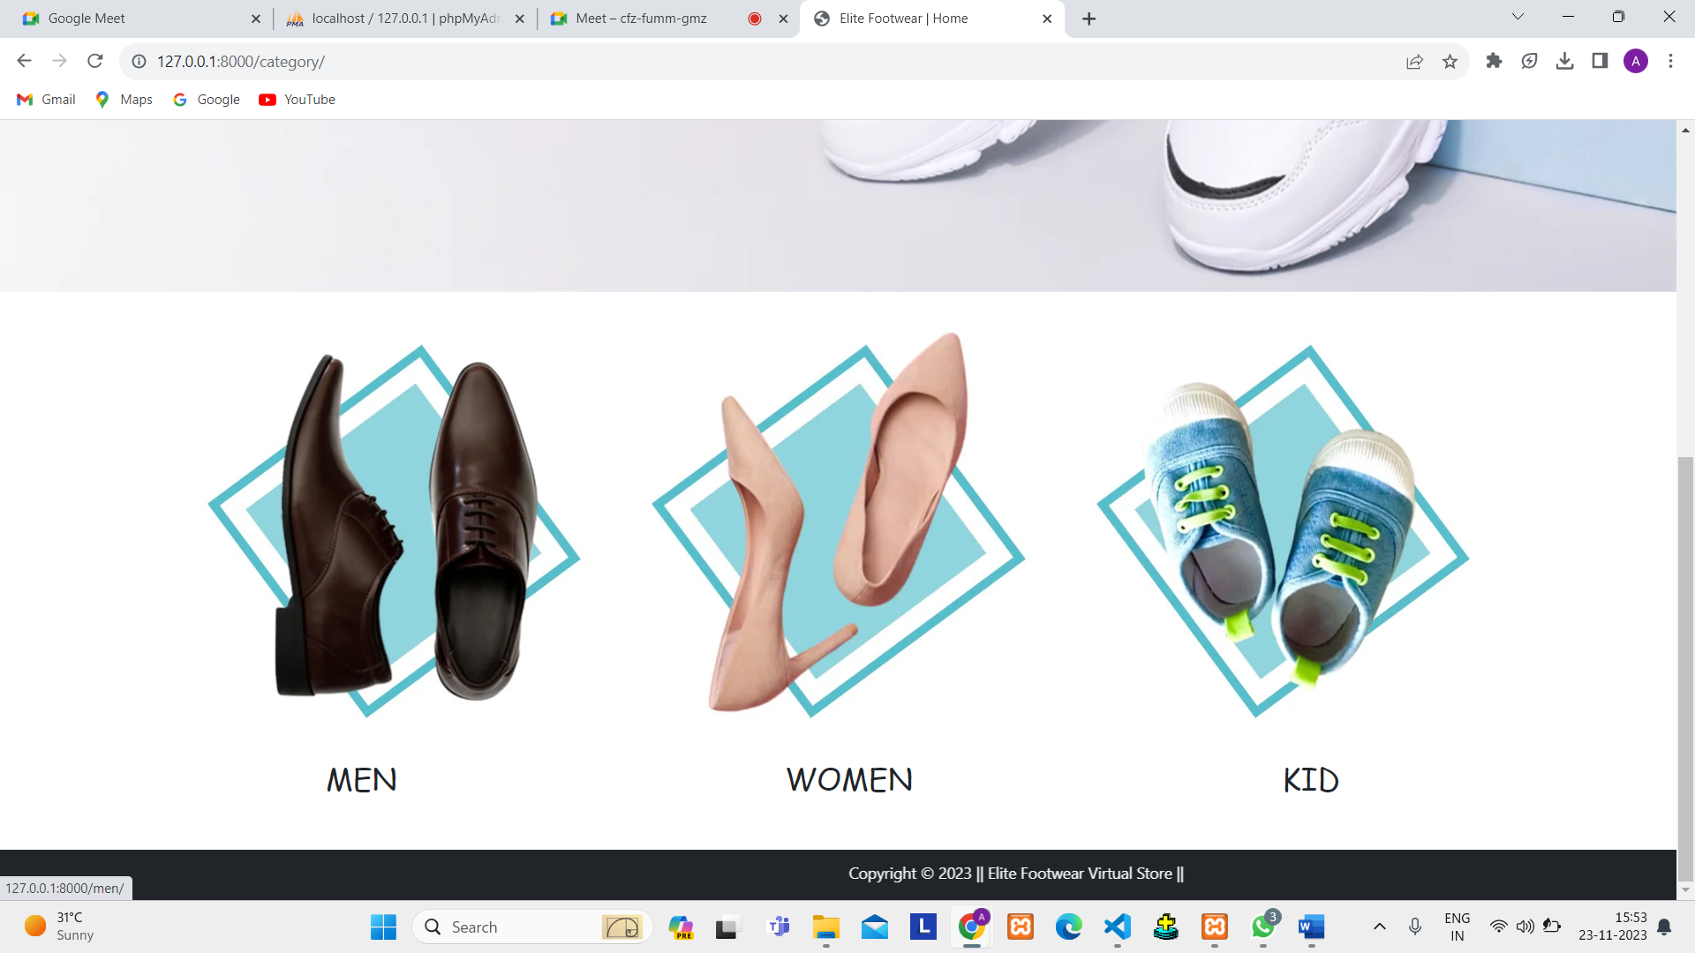

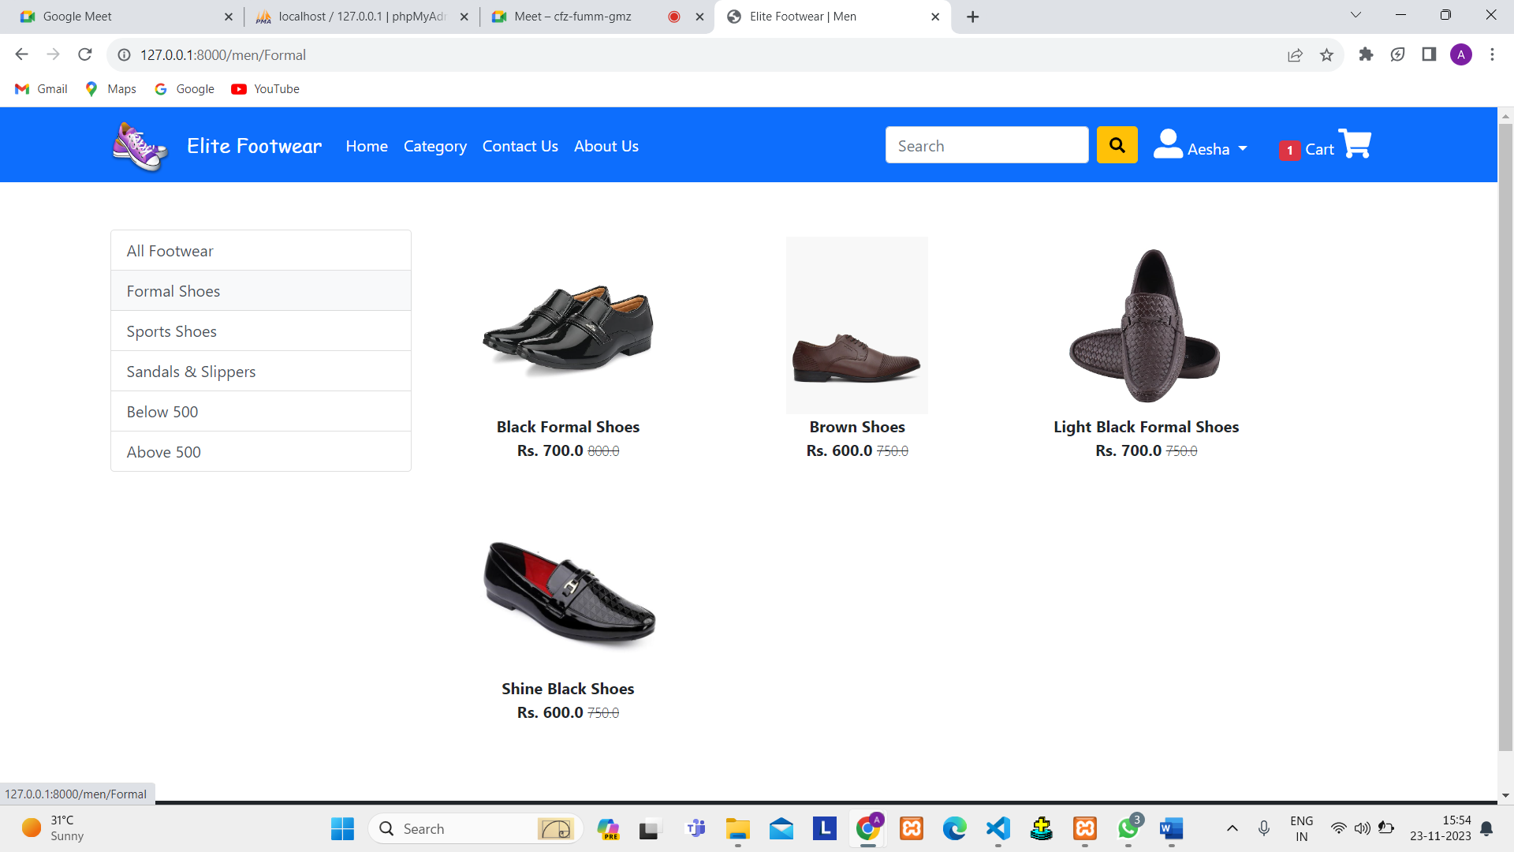

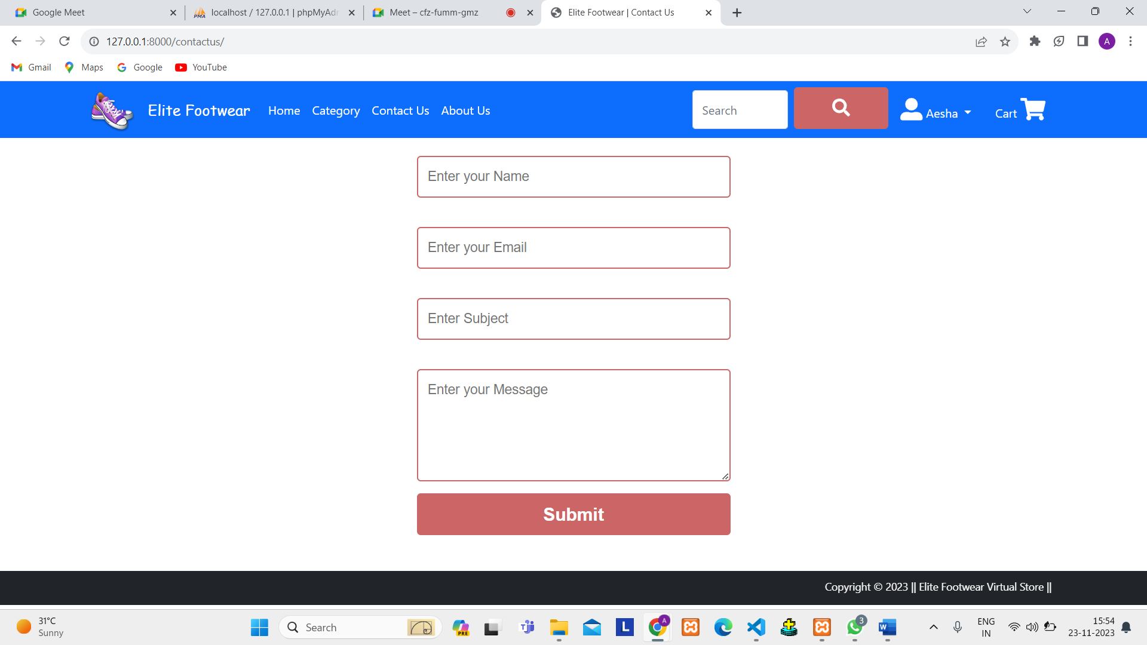

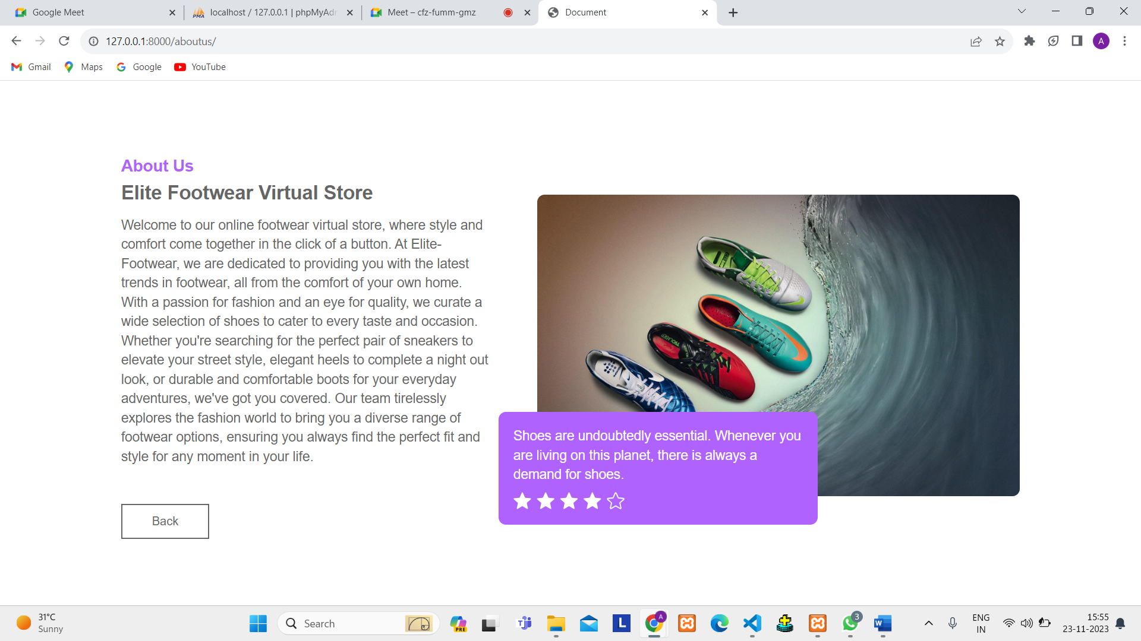

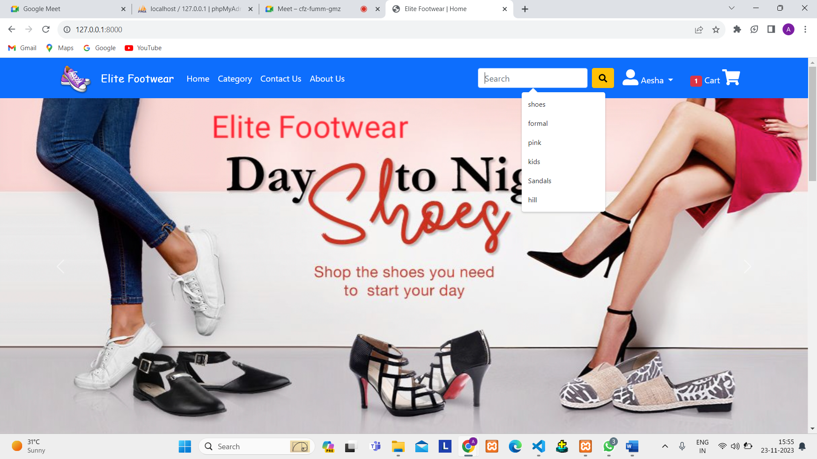

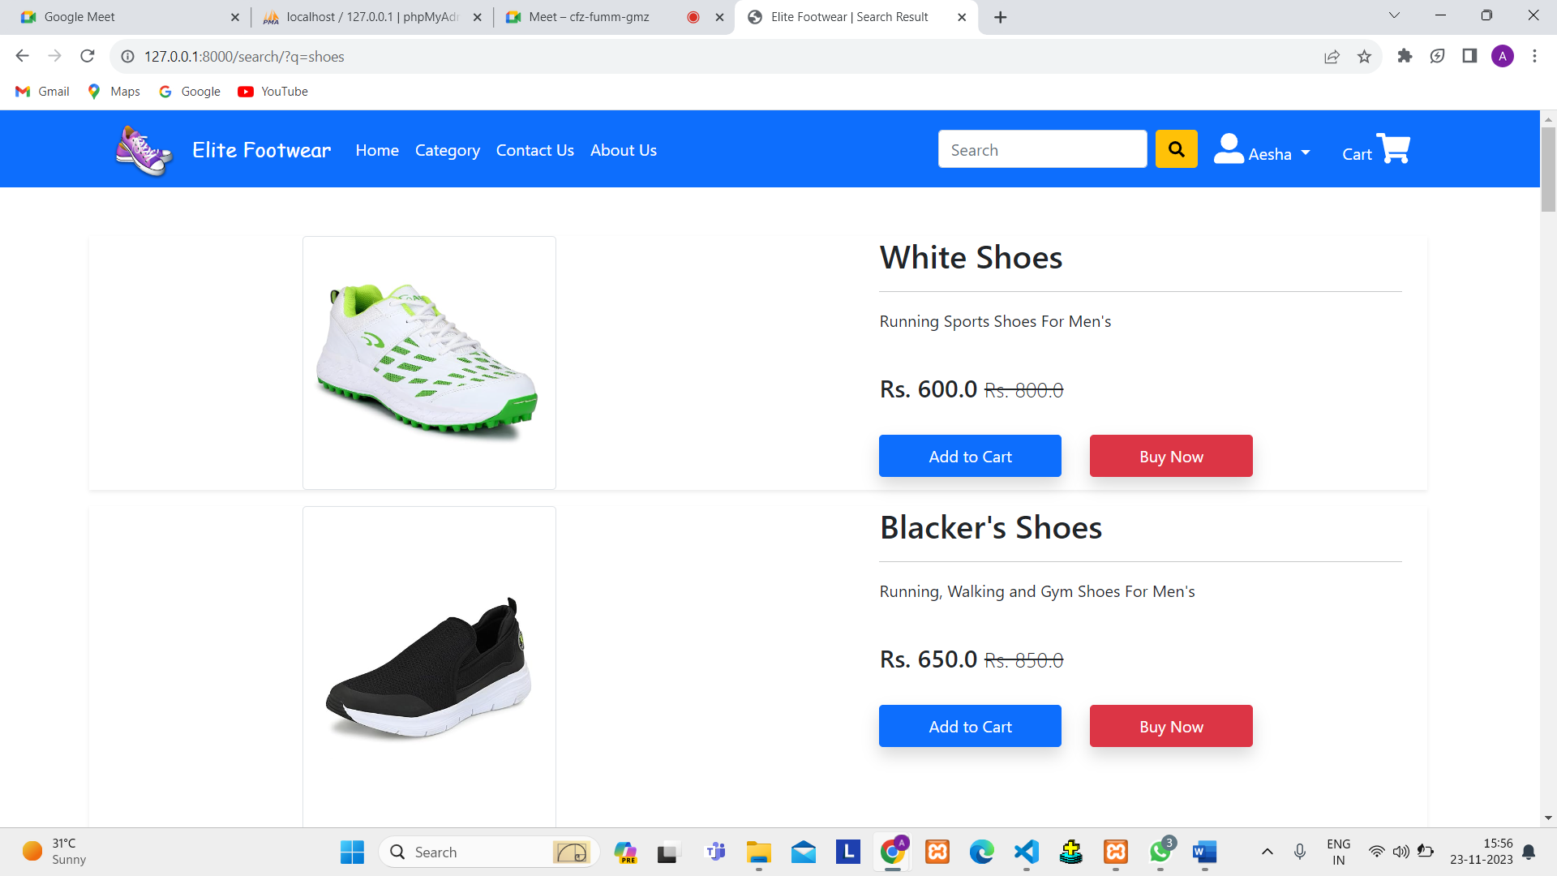

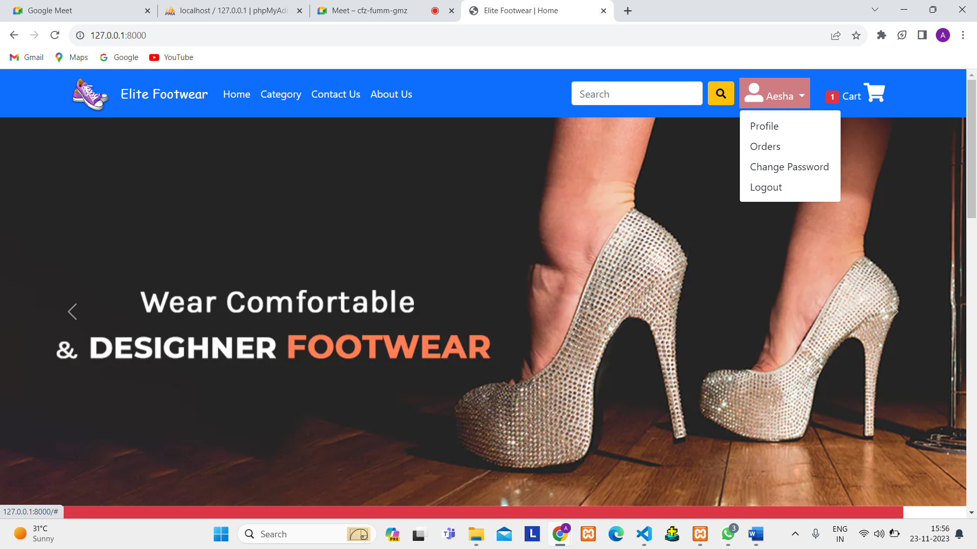

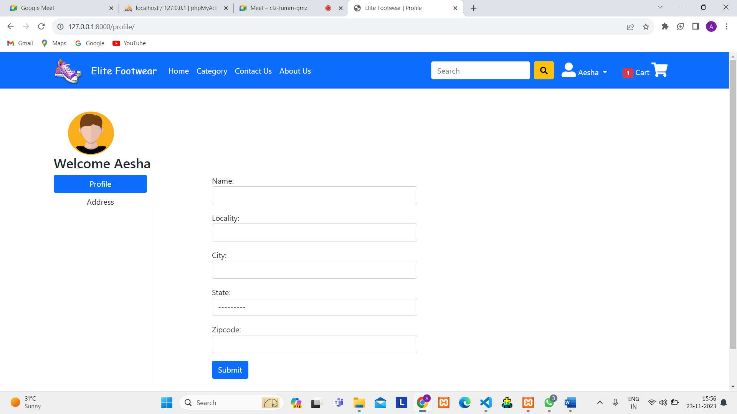

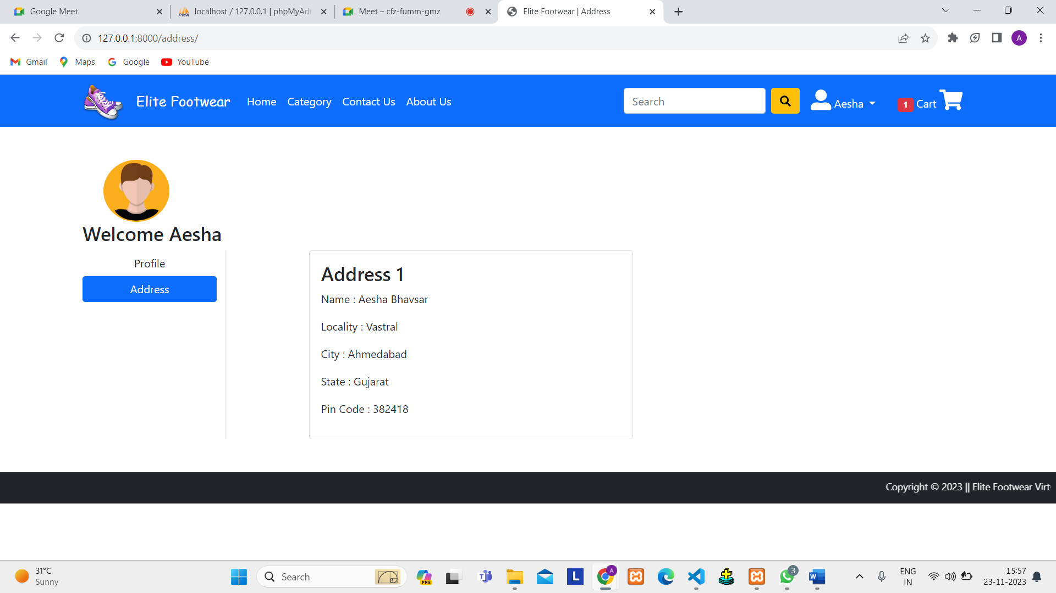

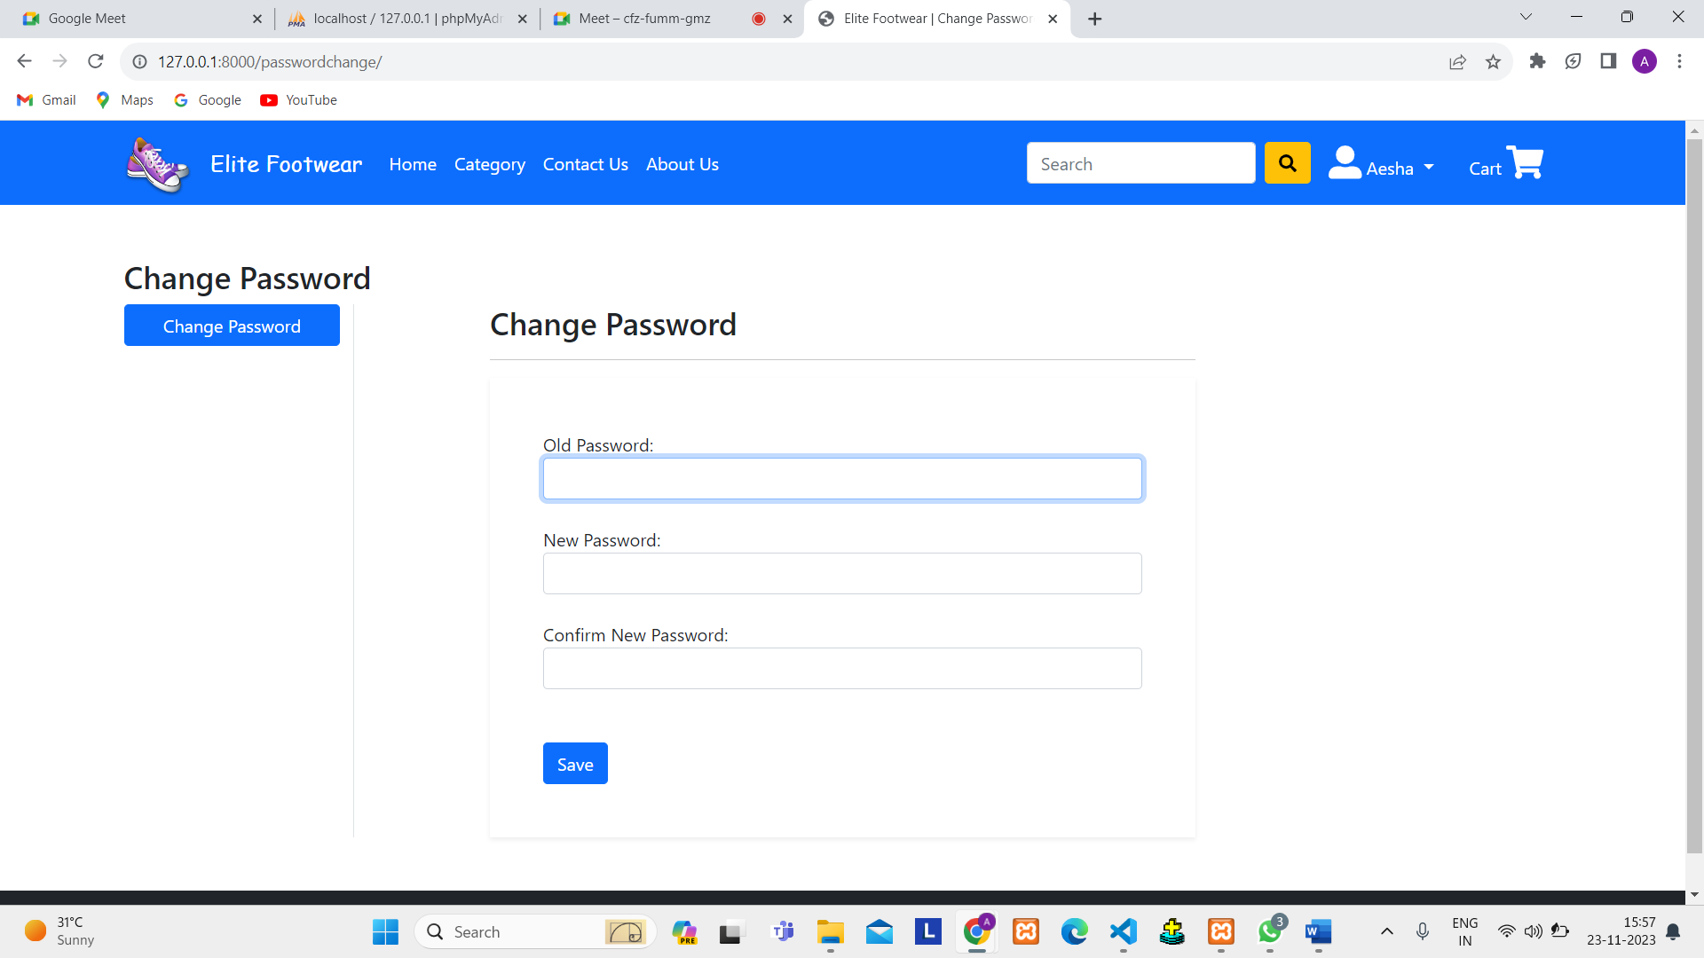

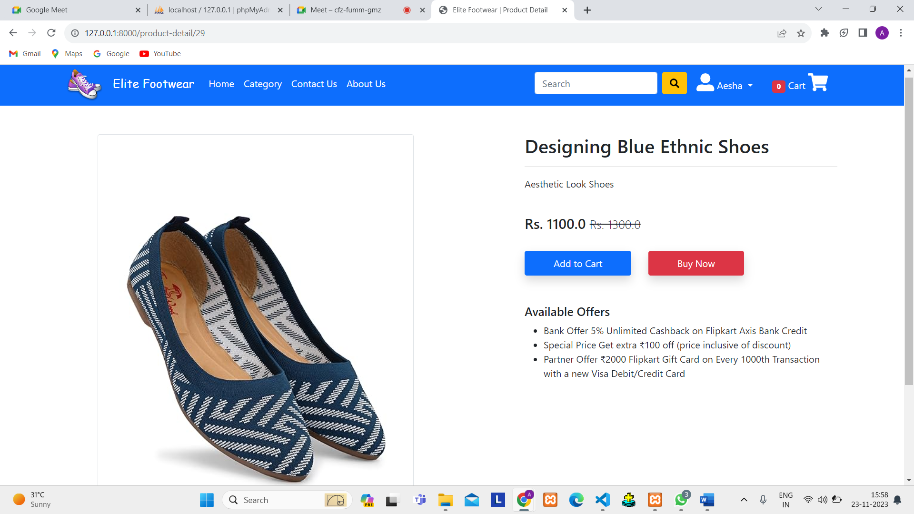

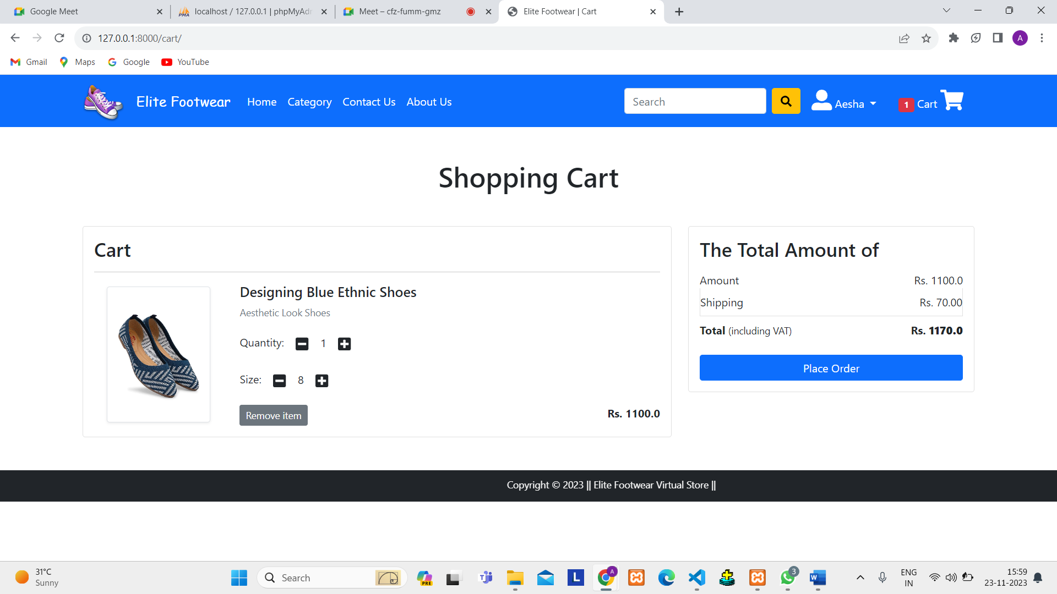

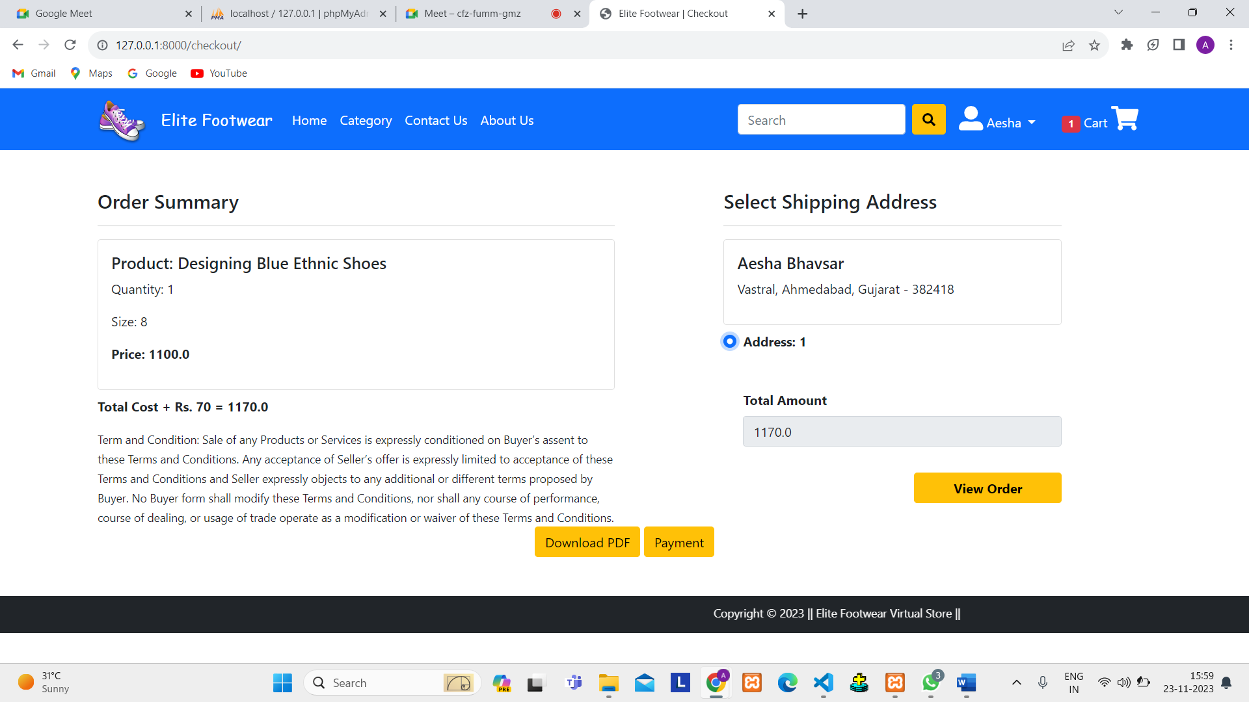

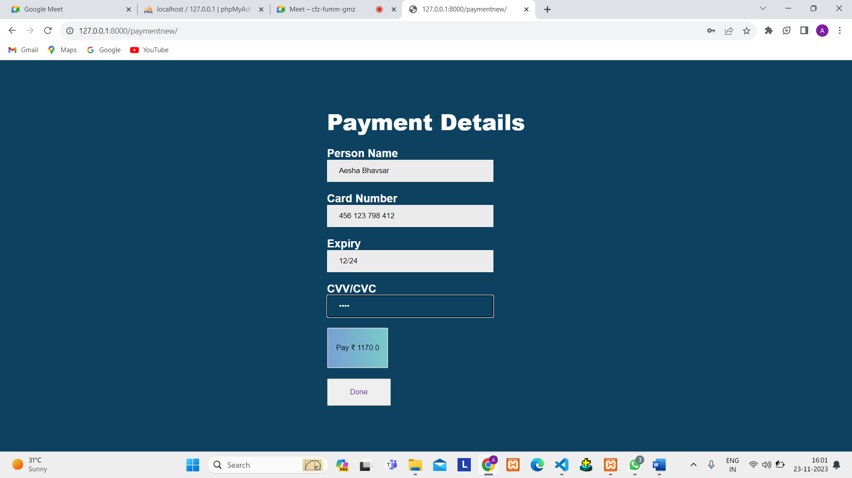

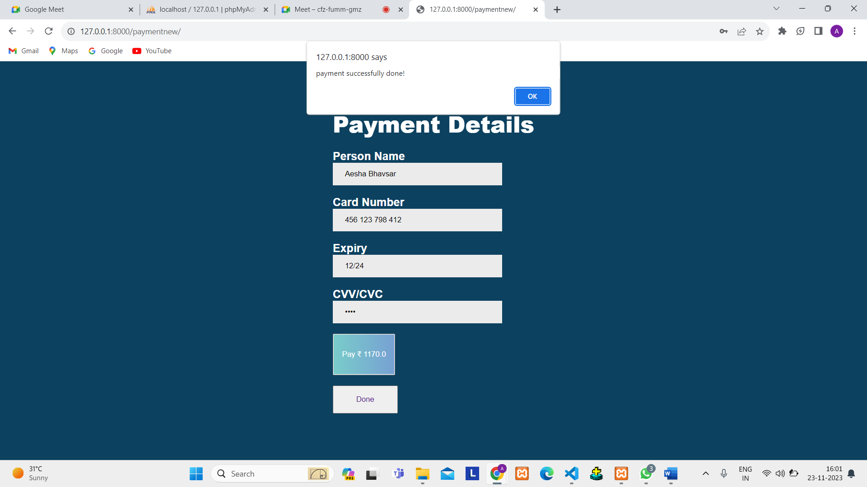

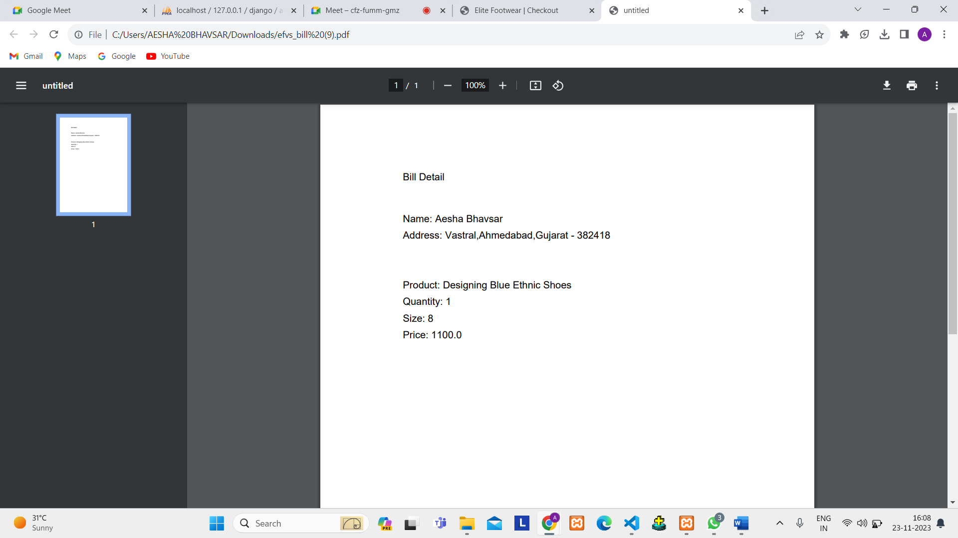

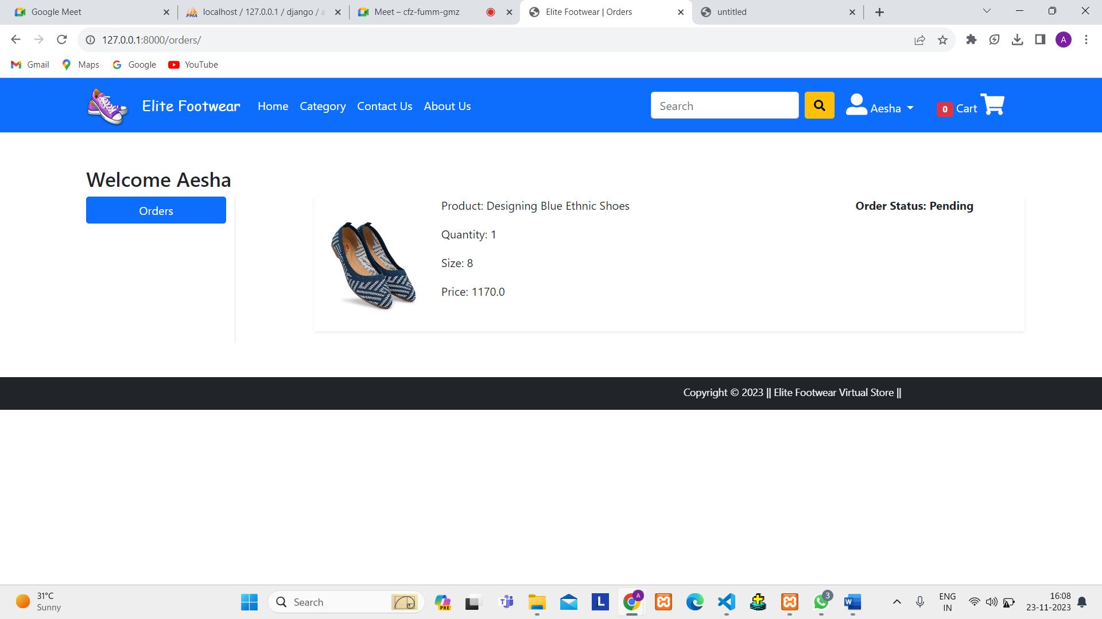

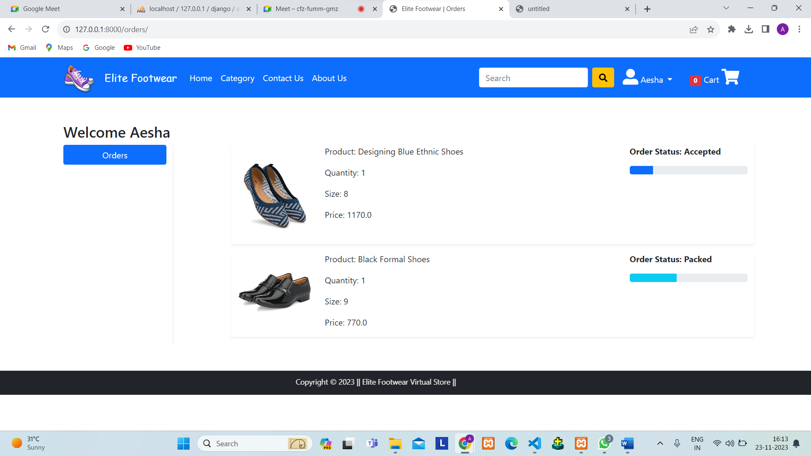

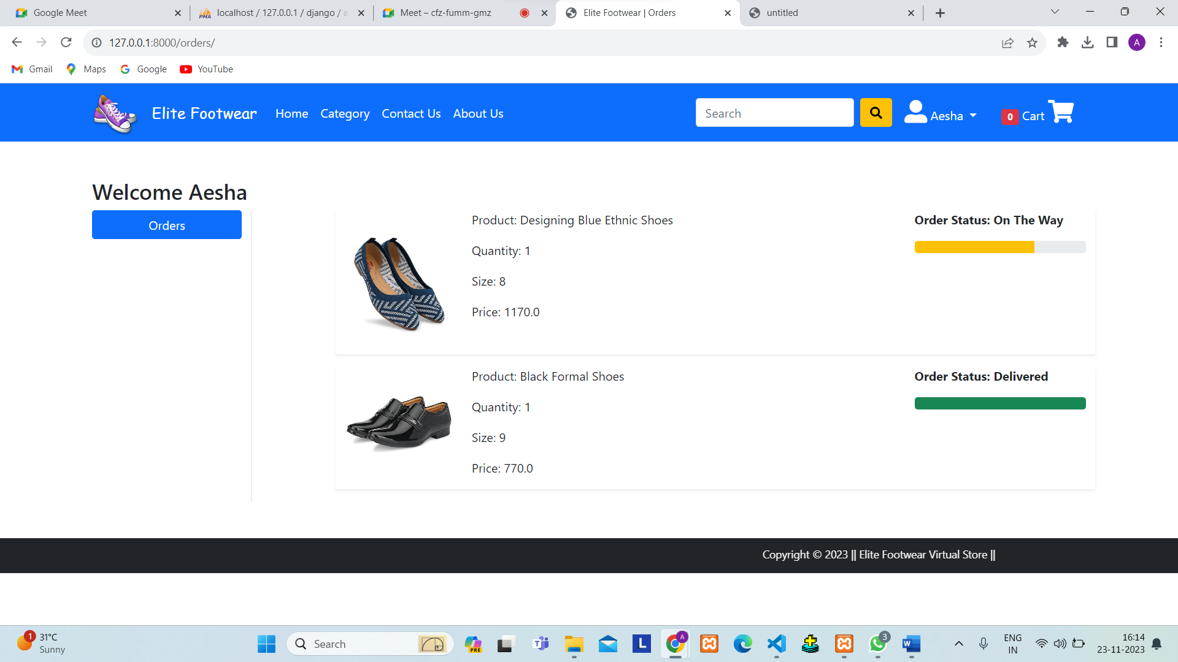

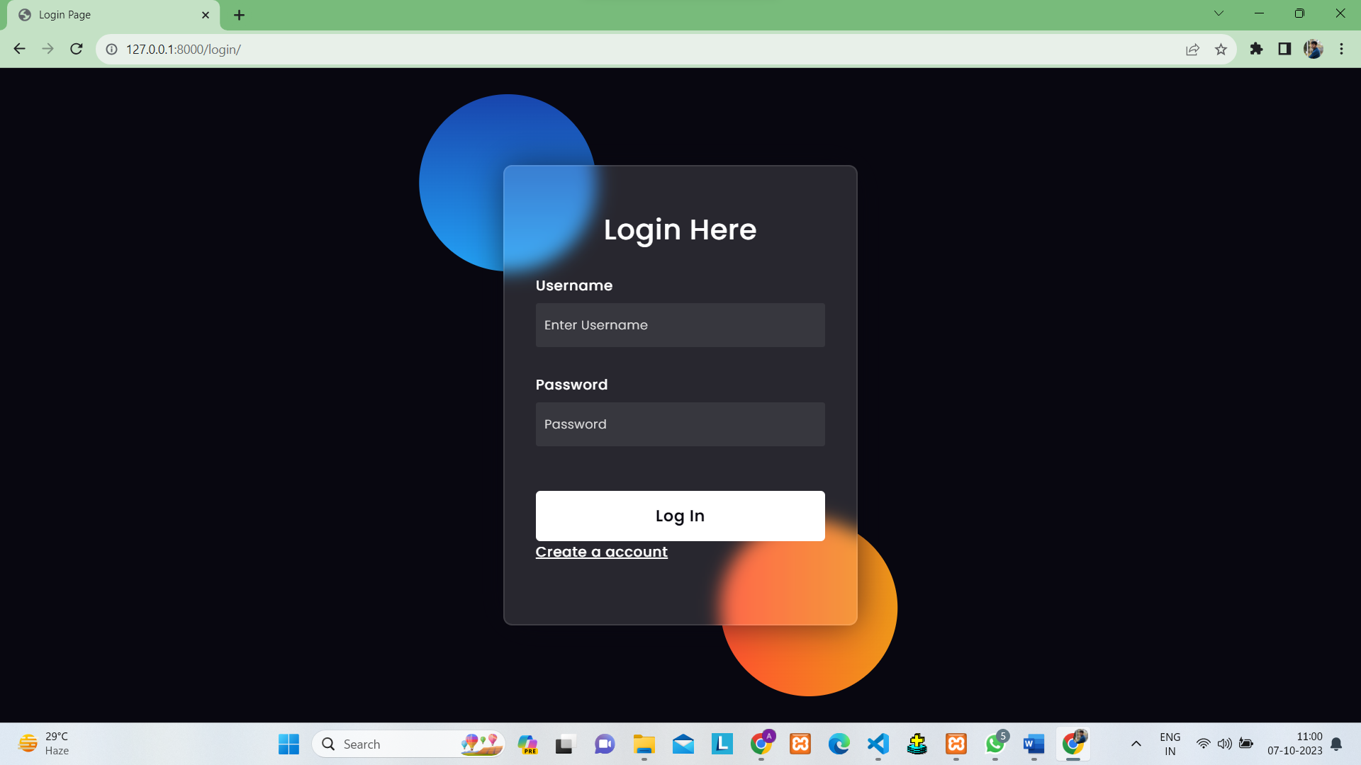

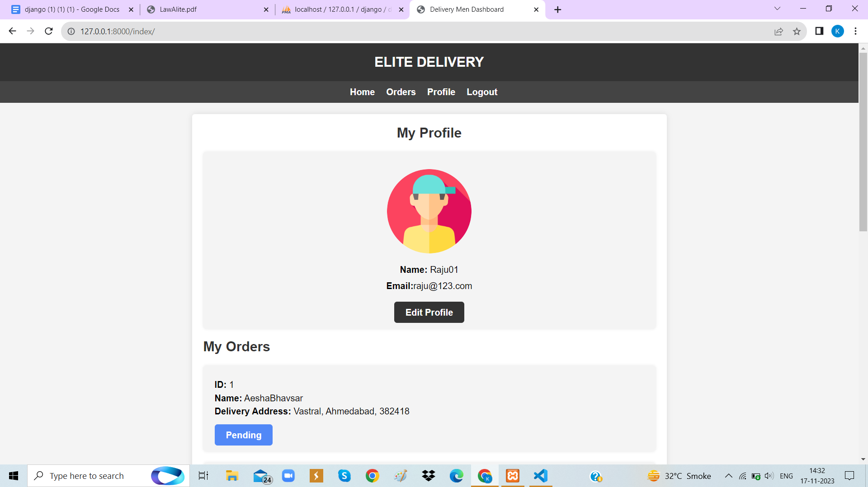

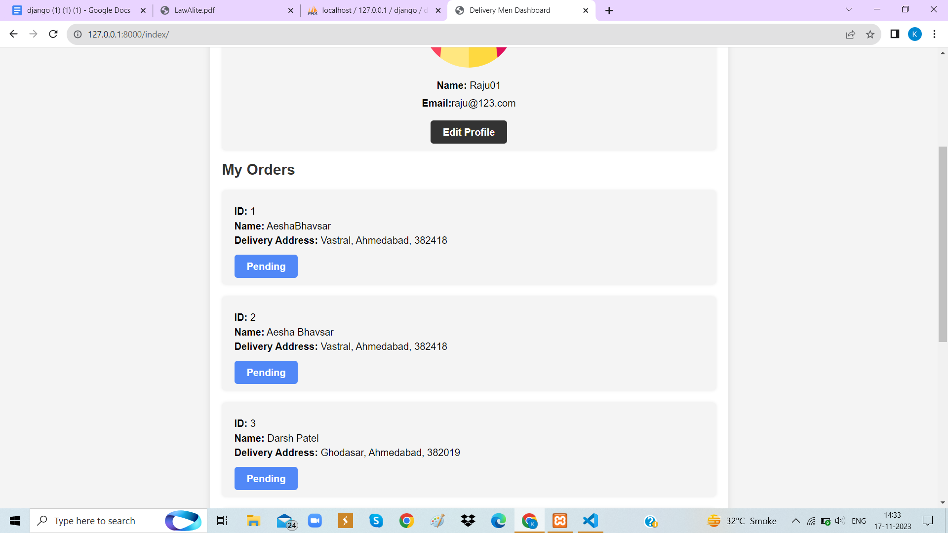

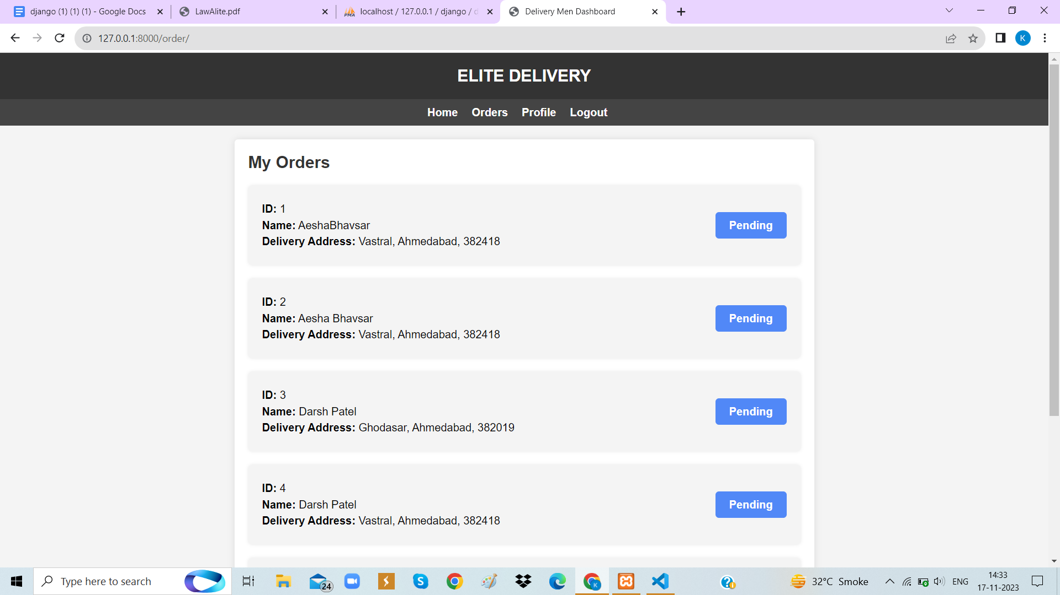

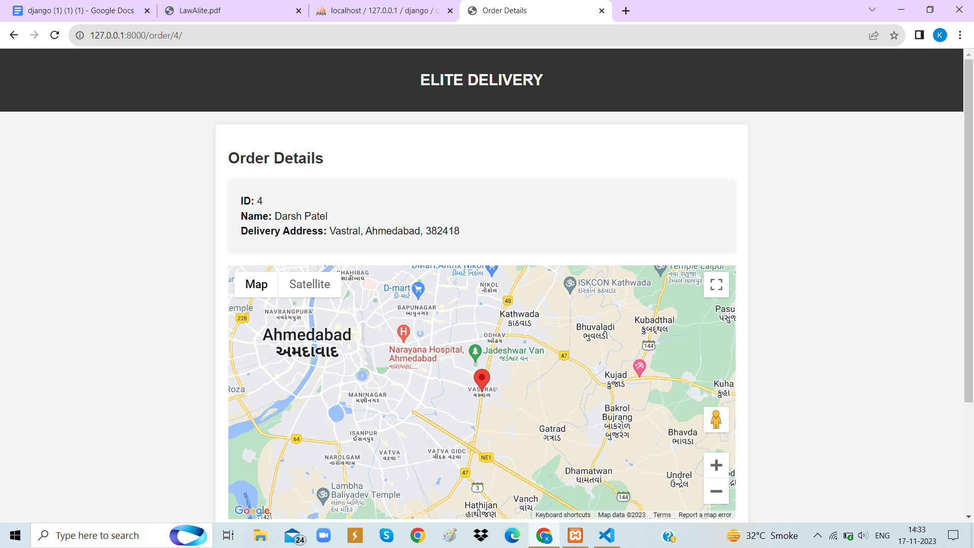

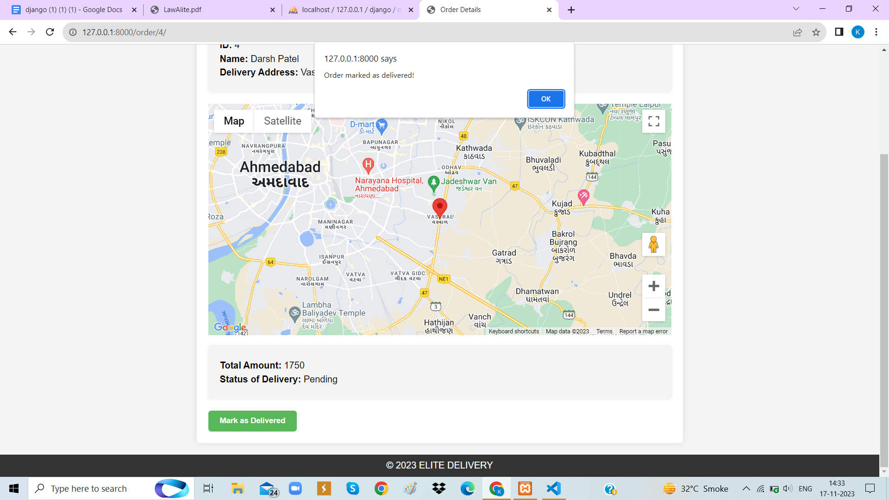

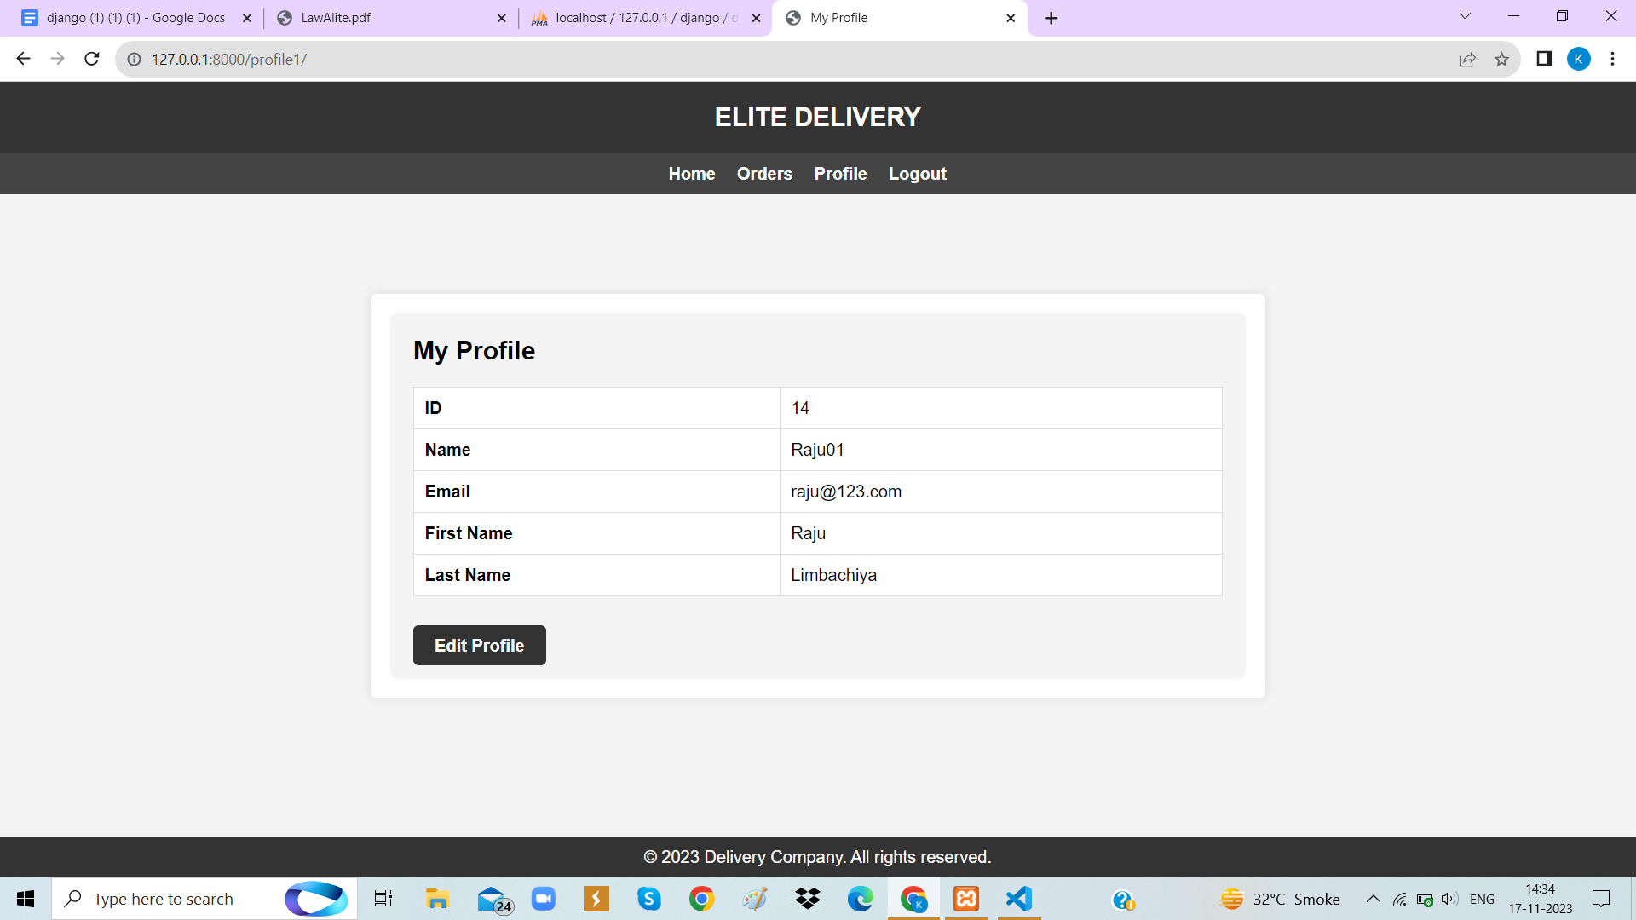

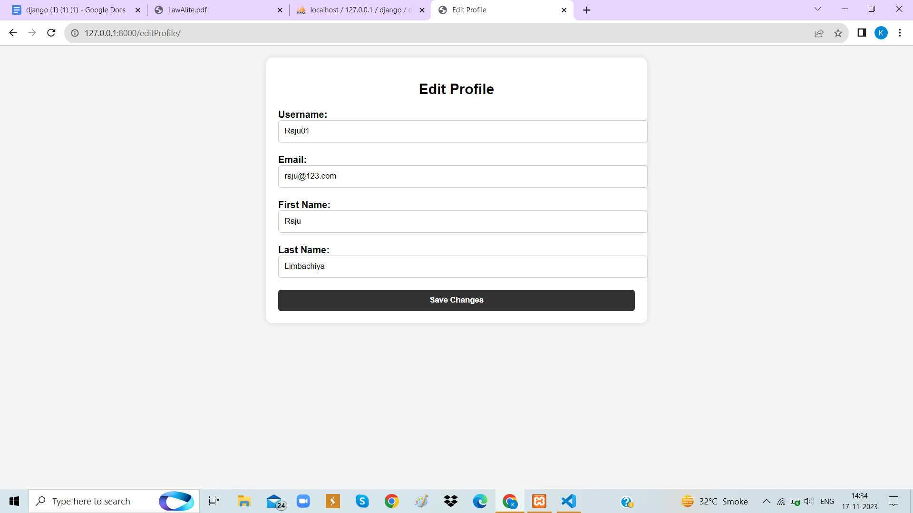

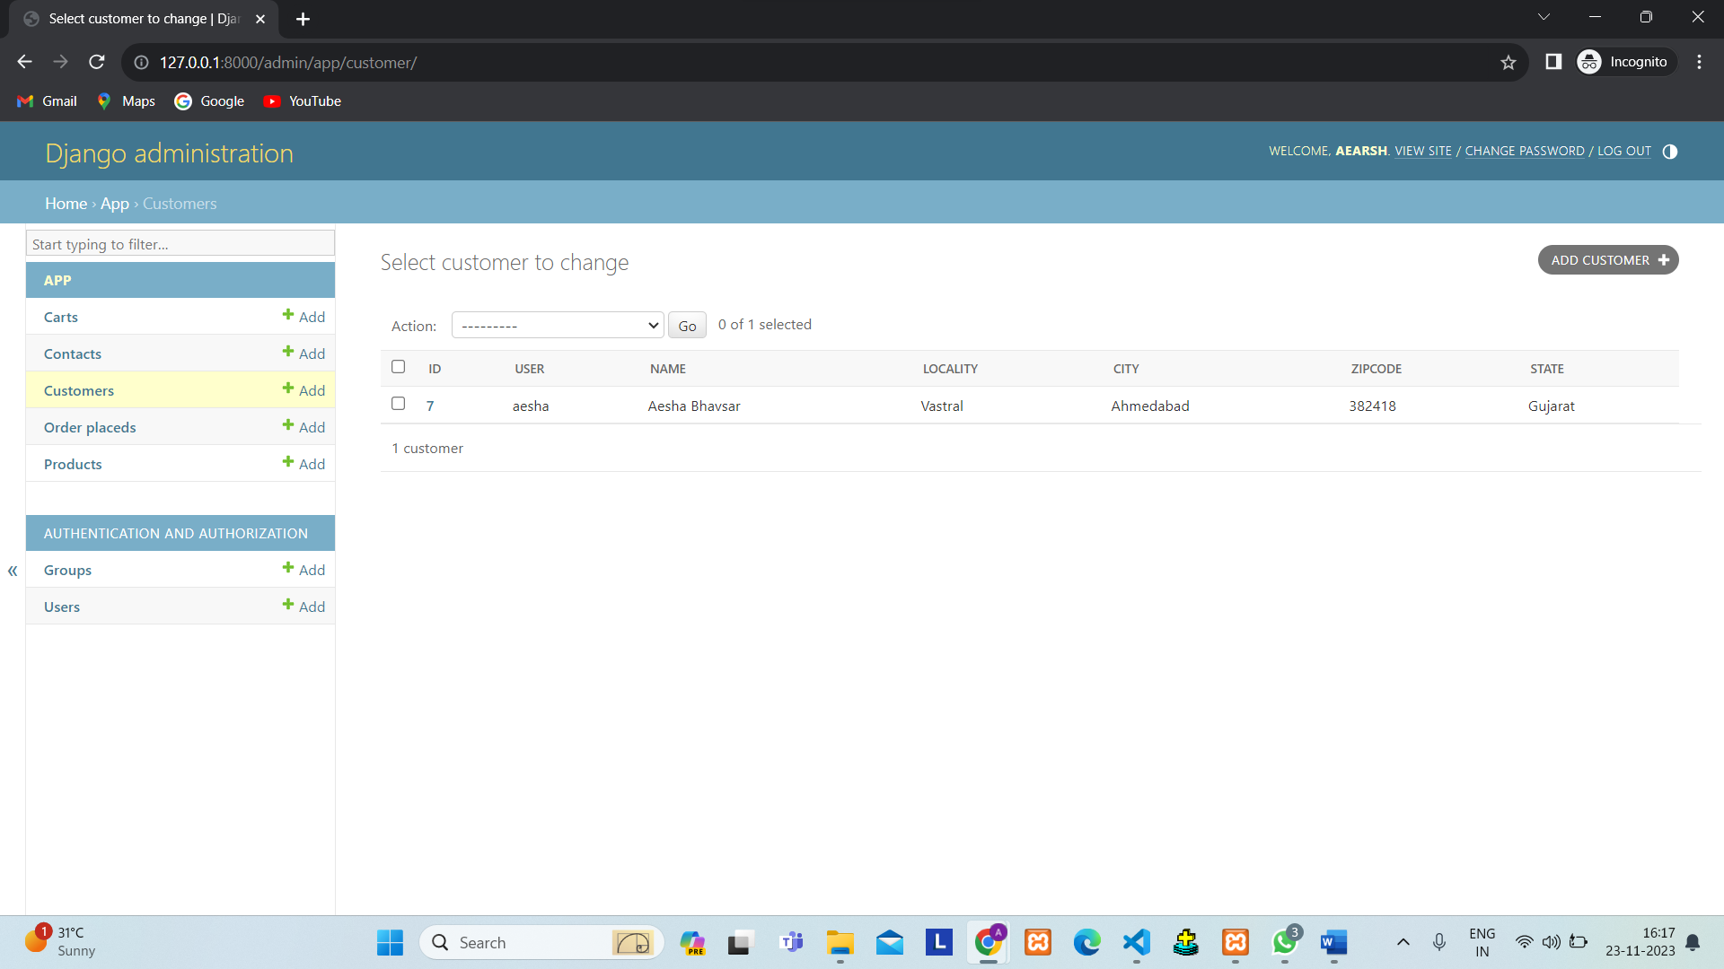

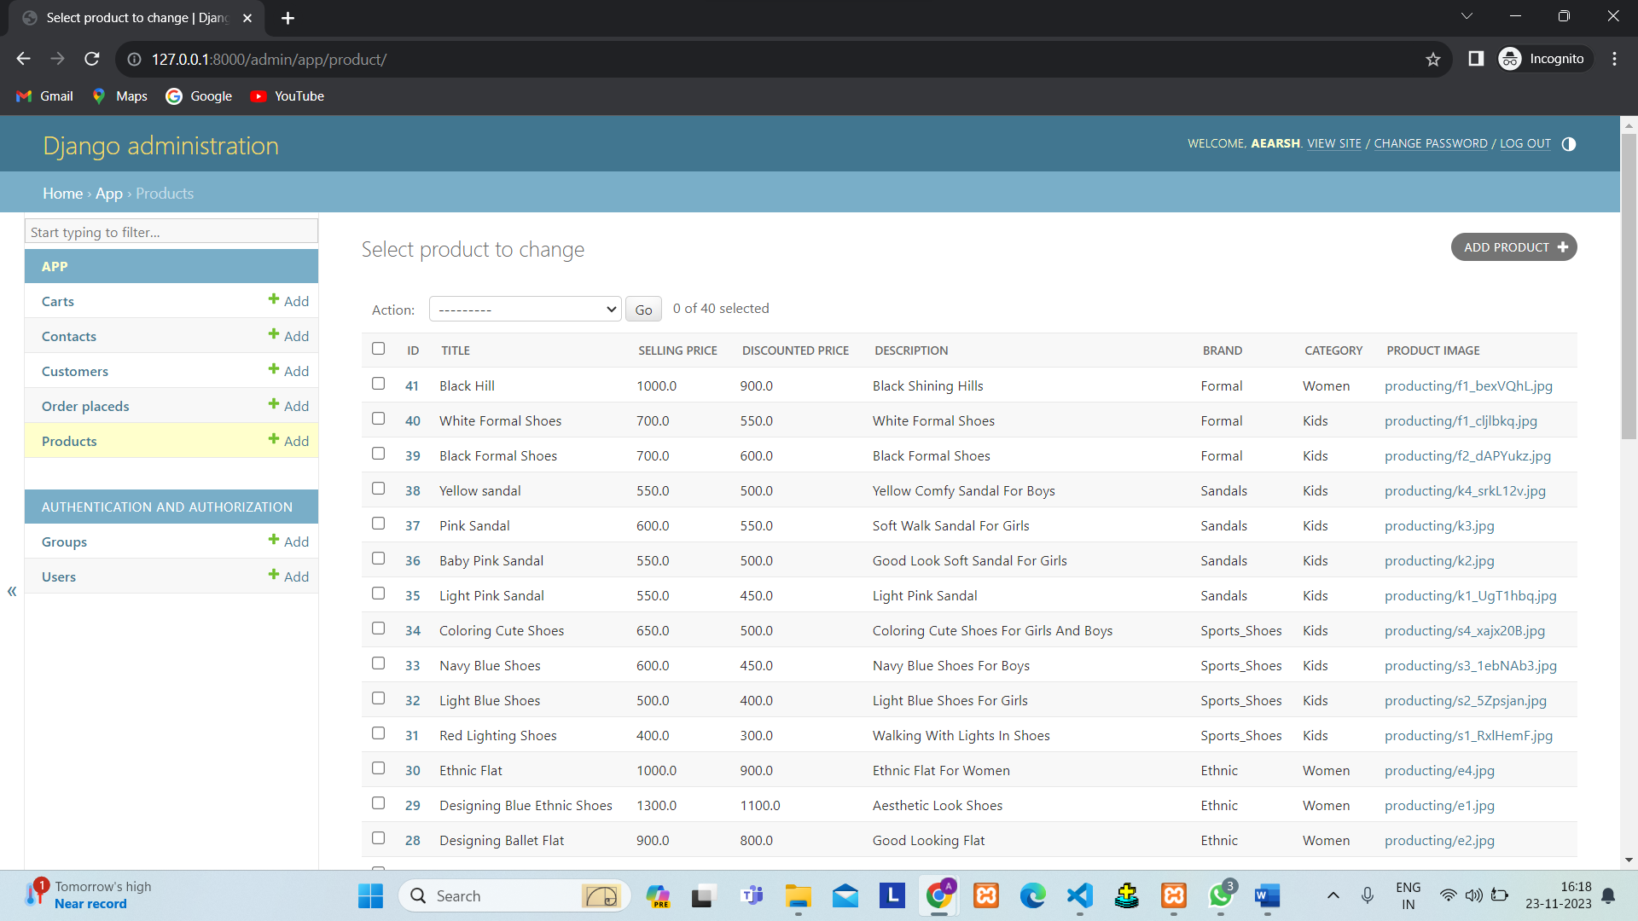

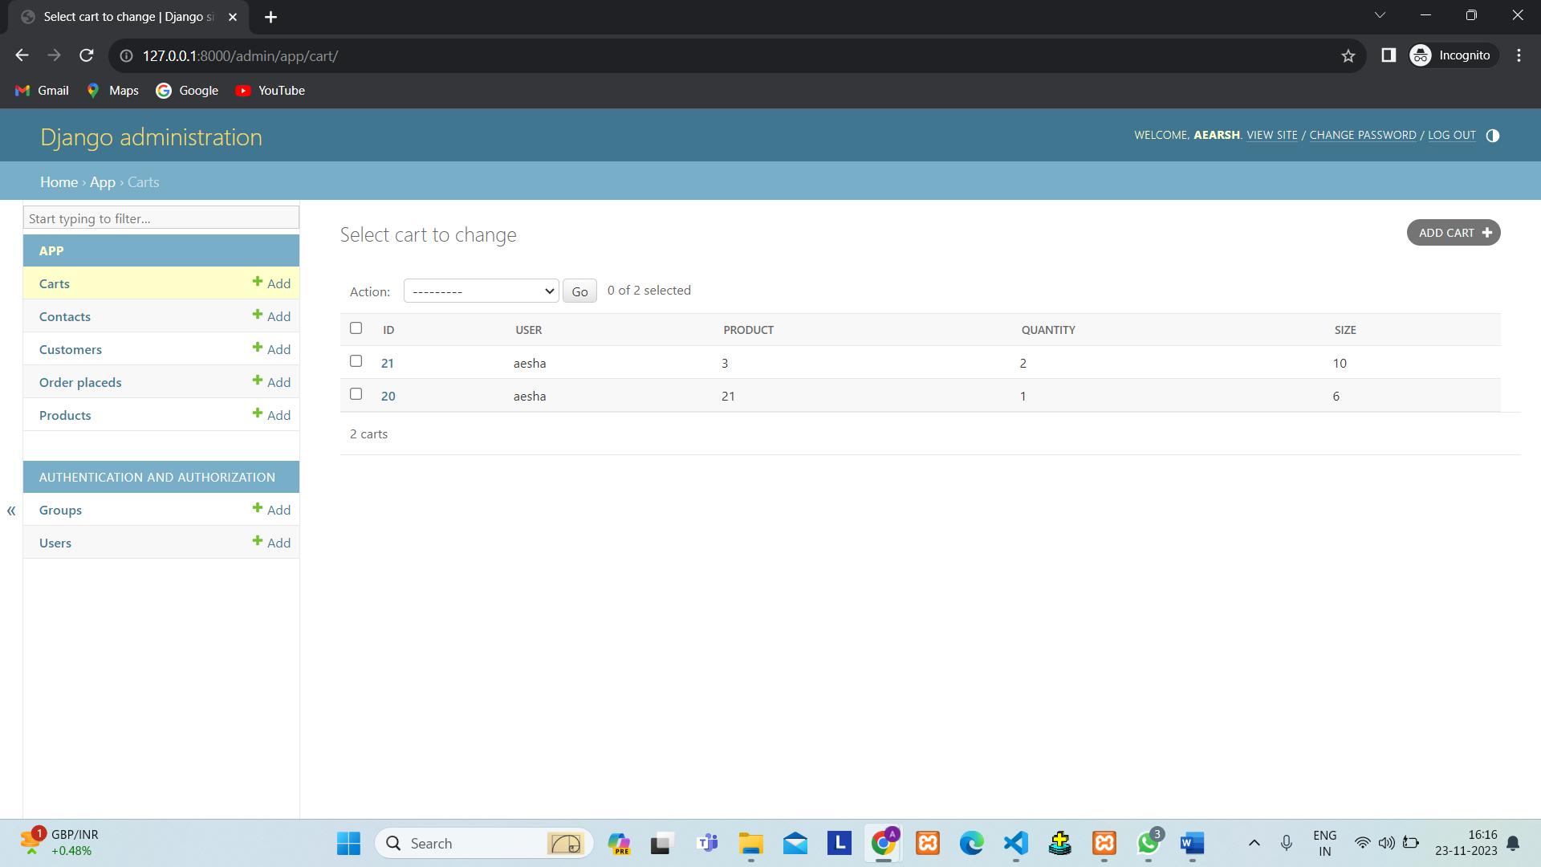

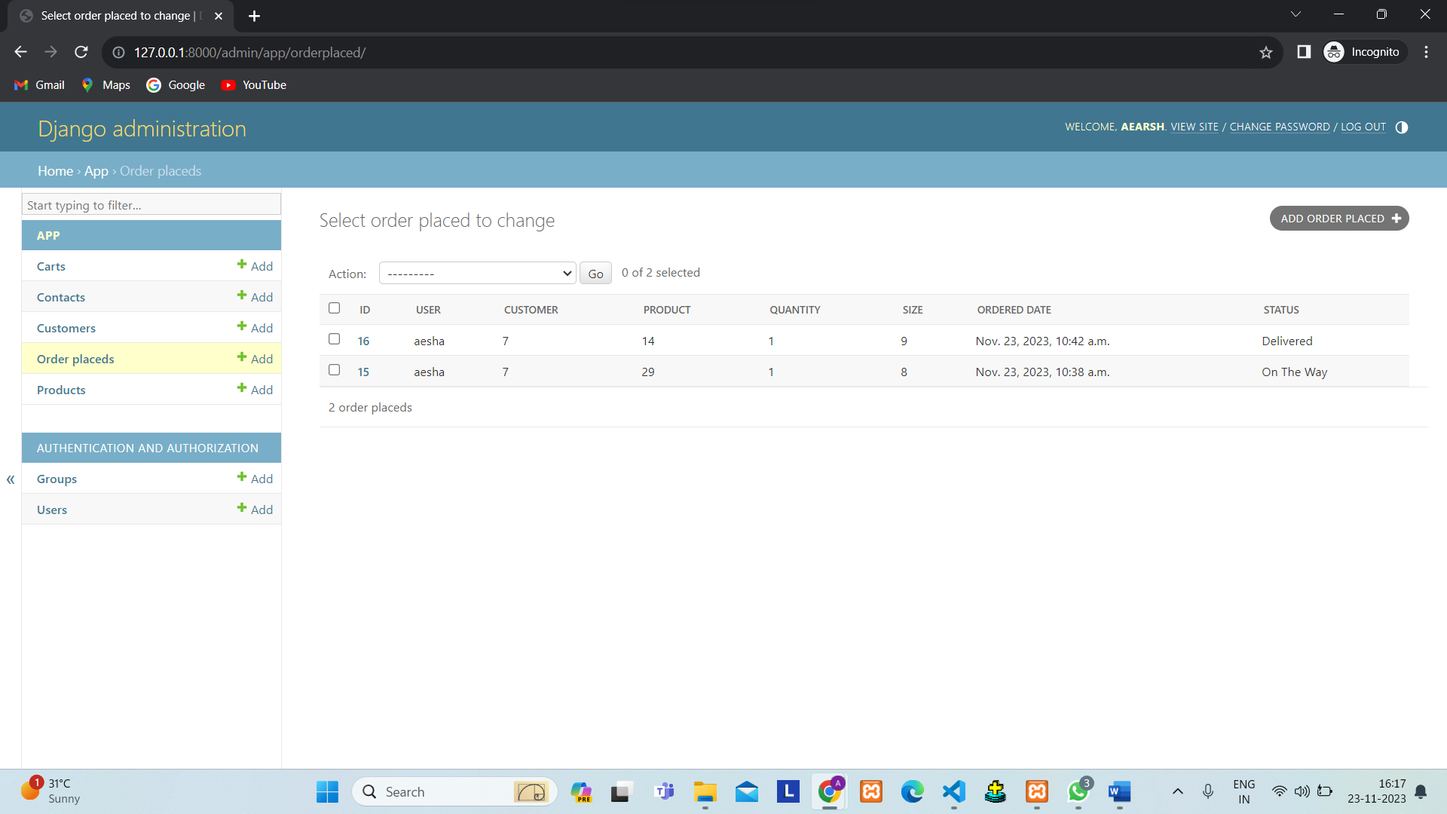

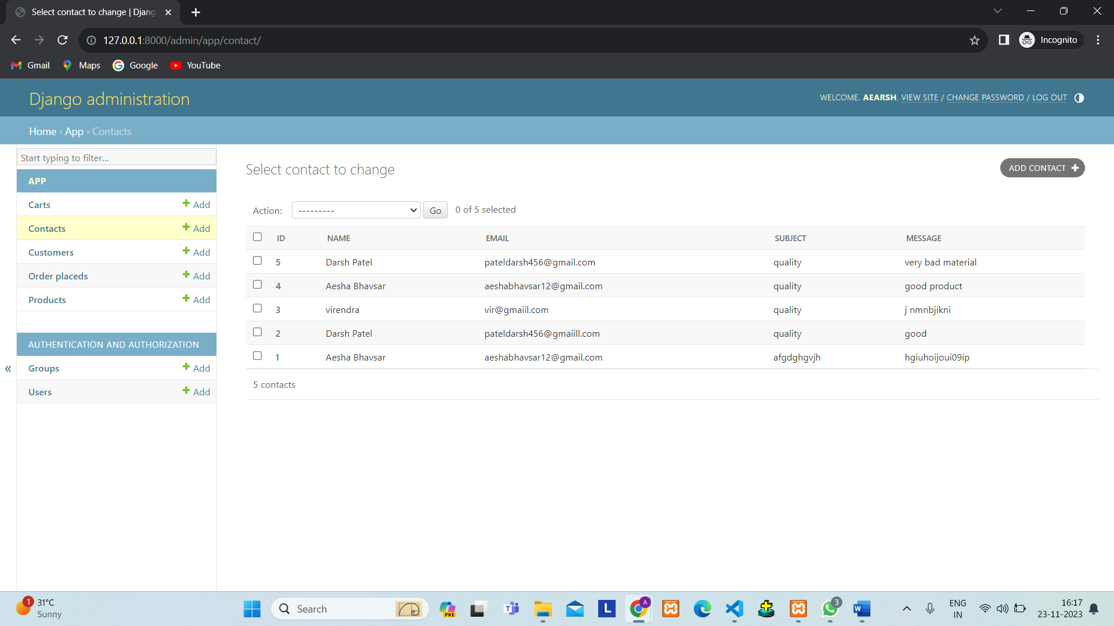

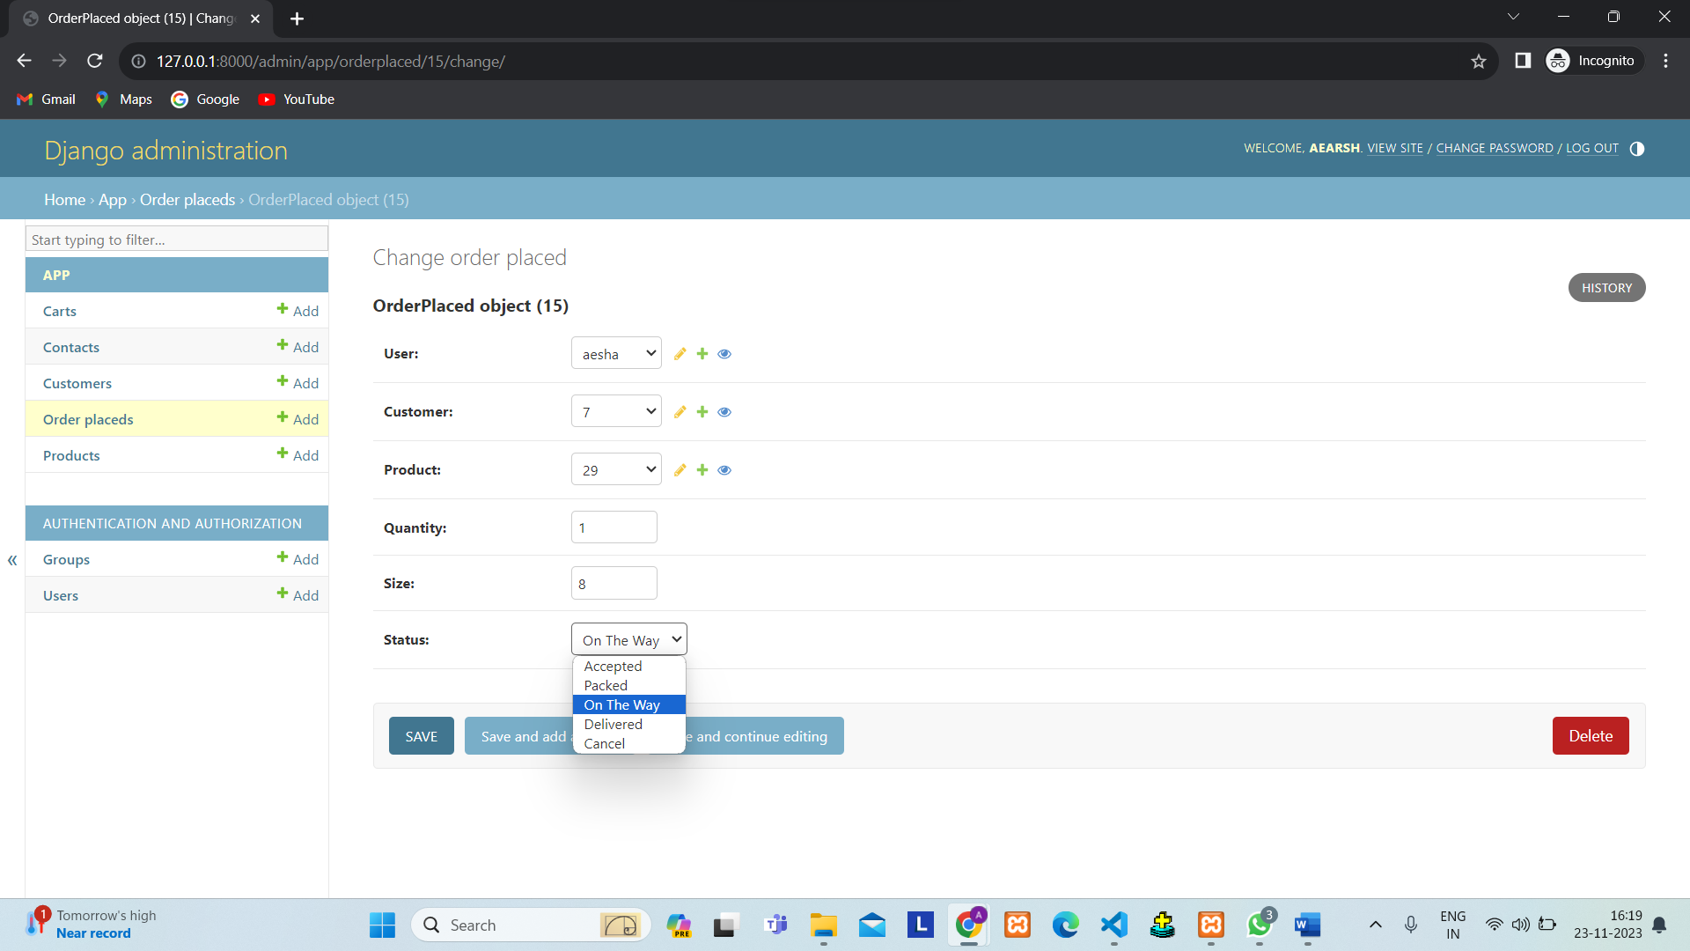

**5. Agile Documentation**

**5.1 Agile Project Charter**

|  |  |
| --- | --- |
| Project Name | Elite Footwear Virtual Store |
| Stakeholders | Customers, Administrators, Developers |
| Project Expected Start Date | 22-06-2023 |
| Project Expected End Date | 31-11-2023 |
| Project Scope | Includes user registration, product catalog, shopping cart, secure checkout, and order tracking; excludes payment processing and extensive social media integration. |
| Project Mission | The mission of the Online Footwear Shopping System project is to transform the way people shop for footwear by providing a seamless and enjoyable online shopping experience. |
| Project Vision | To revolutionize online footwear shopping by providing a user-friendly platform with a vast product catalog. |

**5.2 Agile Roadmap / Schedule**

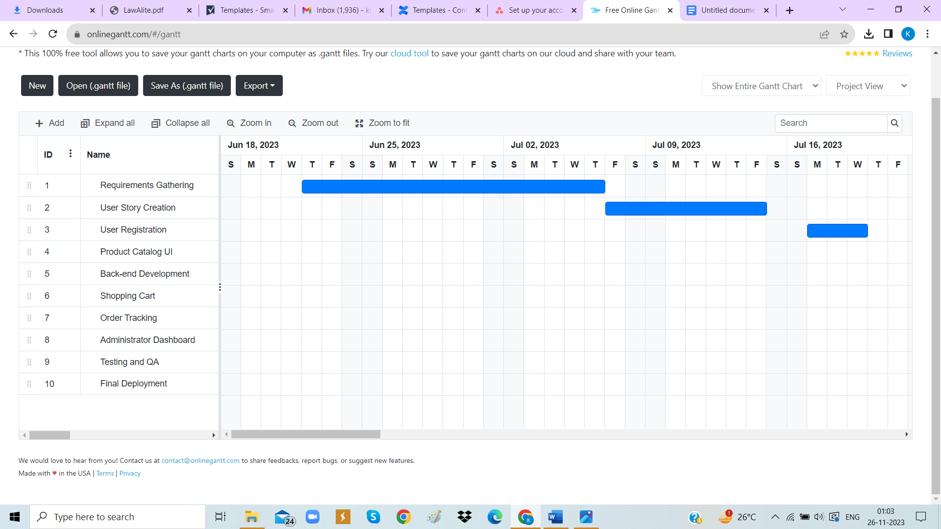

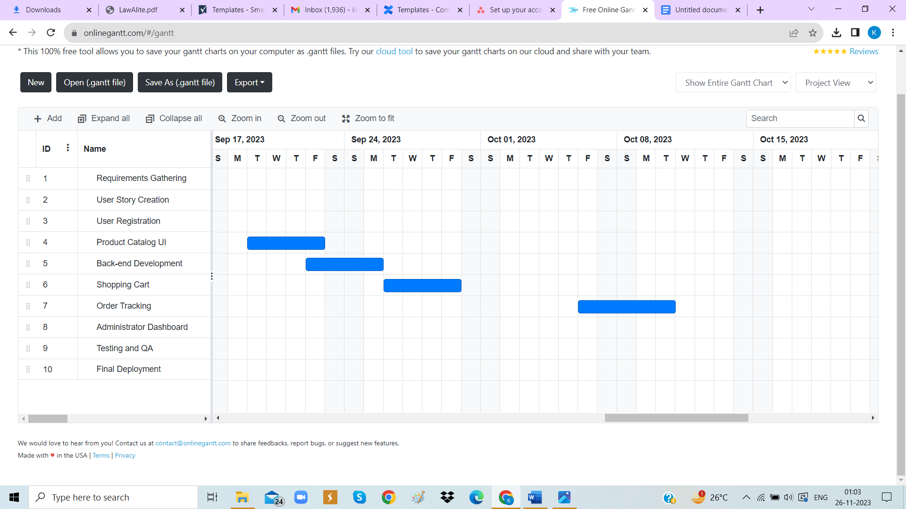

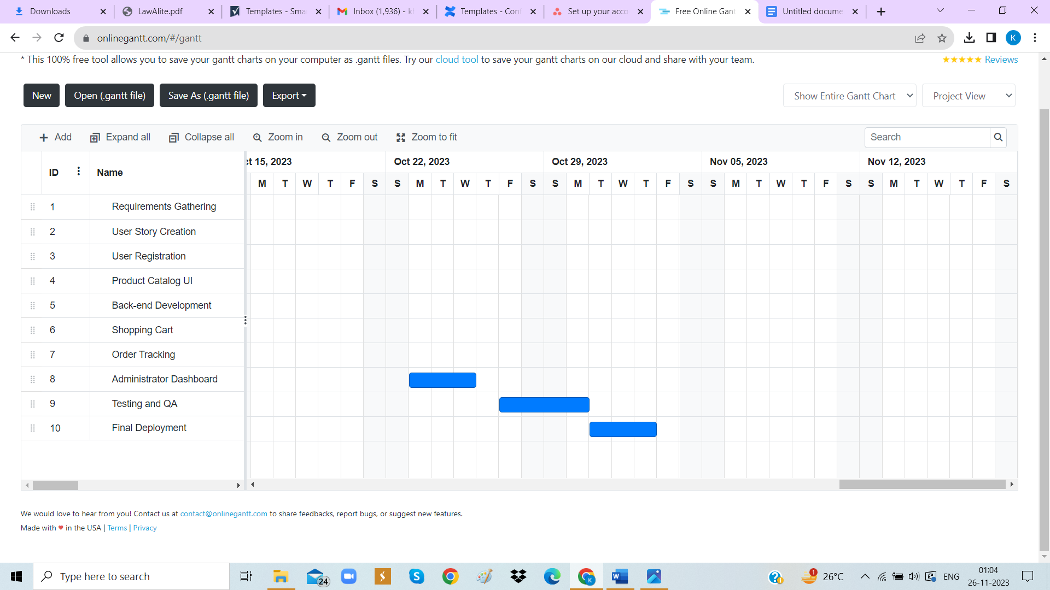

**5.3 Agile Project Plan**

|  |  |  |  |  |
| --- | --- | --- | --- | --- |
| **Task Name** | **Duration** | **Start Date** | **Finish Date** | **Status** |
| Requirements Gathering | 15 days | 22-6-2023 | 6-7-2023 | Completed |
| User Story Creation | 8 days | 8-7-2023 | 15-7-2023 | Completed |
| User Registration | 2 days | 15-9-2023 | 17-9-2023 | Completed |
| Product Catalog UI | 3 days | 19-9-2023 | 22-9-2023 | Completed |
| Back-end Development | 2 days | 23-9-2023 | 25-9-2023 | Completed |
| Shopping Cart | 5 days | 26-9-2023 | 30-9-2023 | Completed |
| Order Tracking | 5 days | 6-9-2023 | 10-9-2023 | Completed |
| Administrator Dashboard | 2 days | 23-9-2023 | 25-9-2023 | Completed |
| Testing and QA | 3 days | 27-10-2023 | 30-10-2023 | Completed |
| Final Deployment | 2 day | 31-10-2023 | 2-11-2023 | Completed |

**5.4 Agile User Story (Minimum 3 Tasks)**

|  |  |  |  |  |
| --- | --- | --- | --- | --- |
| **User Type** | **Perform Task** | **Achieve Goal** | **Priority** | **Delivery Role** |
| Customer | Create an account | Save personal information and easily access order history | Medium | Backend Developer |
| Customer | Browse footwear products by category | Quickly find the type of shoes of interest | High | Frontend Developer |
| Customer | Search for footwear products | Narrow down options and find the perfect pair of shoes | High | Full Stack Developer |
| Customer | View detailed product information | Make informed purchasing decisions | Medium | Frontend Developer |
| Customer | Add products to the shopping cart | Compile desired items for purchase | High | Full Stack Developer |
| Customer | Checkout and make payments | Complete the purchase and provide payment securely | High | Full Stack Developer |
| Customer | Receive order confirmation emails | Obtain order details and confirmation | Medium | Backend Developer |
| Customer | Manage user profile | Update personal information and track order history | Medium | Full Stack Developer |
| Customer | Leave product reviews and ratings | Share feedback and help other customers make informed decisions | Low | Full Stack Developer |
| Customer | Track the status of orders | Stay informed about the progress of the delivery | Medium | Backend Developer |
| Customer | Contact customer support | Seek assistance or resolve any issues encountered | High | Full Stack Developer |
| Administrator | Manage the product catalog | Add, edit, and delete products | High | Backend Developer |
| Administrator | Manage customer orders | View and update order status and track shipments | High | Backend Developer |
| Administrator | Manage user accounts | Handle user registration, authentication, and account settings | Medium | Backend Developer |
| Administrator | Generate reports and analytics | Gain insights into customer preferences, product popularity, and sales | Medium | Backend Developer |
| Administrator | Manage discounts and promotions | Create and manage promotional offers and discounts | Low | Backend Developer |
| Delivery Man | Receive delivery assignments | Get notified about orders to be delivered | High | Delivery Team |
| Delivery Man | Pick up products from the warehouse | Collect the ordered products from the designated location | High | Delivery Team |
| Delivery Man | Deliver products to customers | Ensure timely and accurate delivery of orders to the customers | High | Delivery Team |
| Delivery Man | Update delivery status | Mark orders as delivered and provide real-time updates to the system | Medium | Delivery Team |

**5.5 Agile Release Plan**

|  |  |  |  |  |  |
| --- | --- | --- | --- | --- | --- |
| **Task Name** | **Duration (Weeks)** | **Start Date** | **Finish Date** | **Status** | **Release** |
| Requirements Gathering | 15 days | 22-6-2023 | 6-7-2023 | Completed | 6-7-2023 |
| User Story Creation | 8 days | 8-7-2023 | 15-7-2023 | Completed | 15-7-2023 |
| User Registration | 2 days | 15-9-2023 | 17-9-2023 | Completed | 17-7-2023 |
| Product Catalog UI | 3 days | 19-9-2023 | 22-9-2023 | Completed | 22-9-2023 |
| Back-end Development | 2 days | 23-9-2023 | 25-9-2023 | Completed | 25-9-2023 |
| Shopping Cart | 5 days | 26-9-2023 | 30-9-2023 | Completed | 30-9-2023 |
| Order Tracking | 5 days | 6-10-2023 | 10-10-2023 | Completed | 10-10-2023 |
| Administrator Dashboard | 2 days | 23-9-2023 | 25-9-2023 | Completed | 25-9-2023 |
| Testing and QA | 3 days | 27-10-2023 | 30-10-2023 | Completed | 30-10-2023 |
| Final Deployment | 2 day | 31-10-2023 | 2-11-2023 | Completed | 2-11-2023 |

**5.6 Agile Sprint Backlog**

|  |  |  |  |  |  |
| --- | --- | --- | --- | --- | --- |
| **Task Name** | **Story** | **Sprint Ready** | **Priority** | **Status** | **Story Point** |
| Requirements Gathering | Requirements Gathering | Yes | High | Completed | 5 |
| User Story Creation | User Story Creation | Yes | High | Completed | 3 |
| User Registration | User Registration | Yes | High | Completed | 8 |
| Product Catalog UI | Product Catalog UI | Yes | High | Completed | 8 |
| Back-end Development | Back-end Development | Yes | High | Completed | 13 |
| Shopping Cart | Shopping Cart | Yes | High | Completed | 5 |
| Order Tracking | Order Tracking | Yes | High | Completed | 8 |
| Administrator Dashboard | Administrator Dashboard | Yes | High | Completed | 13 |
| Testing and QA | Testing and QA | Yes | High | Completed | 5 |
| Final Deployment | Final Deployment | Yes | High | Completed | 3 |

**5.7 Agile Test Plan**

**LOGIN:-**

|  |  |  |  |
| --- | --- | --- | --- |
| **Project Name** | Elite Footwear virtual store | **Device** | intel core i3 10th  gen |
| **Test Case Id** | 1 | **Test Title** | login |
| **Module Name** | login | **Tested** | By Darsh |
| **Priority** | High | **Execution Date** | 27-10-2023 |

|  |  |  |  |  |  |
| --- | --- | --- | --- | --- | --- |
| **Test** | **Test Step** | **Action** | **Expected Result** | **Actual Result** | **Pass** |
| 1 | Navigate to login page | Open login page | Page should be visible | Page is visible | Yes |
| 2 | Login using email and password | Data should be validated and sent to server | Login successfully | Login successfully and Application visible | Yes |

**SEARCH PRODUCT:-**

|  |  |  |  |
| --- | --- | --- | --- |
| **Project Name** | Elite Footwear virtual store | **Device** | intel core i3 10th  gen |
| **Test Case Id** | 2 | **Test Title** | search product |
| **Module Name** | search product | **Tested** | By Aesha |
| **Priority** | High | **Execution Date** | 28-10-2023 |

|  |  |  |  |  |  |
| --- | --- | --- | --- | --- | --- |
| **Test** | **Test Step** | **Action** | **Expected Result** | **Actual Result** | **Pass** |
| 1 | Login using email and password | Data should be validated and sent to server | Login Successfully | Login successfully and Application visible | Yes |
| 2 | Click to Search Product | Search product by ID or Name | Searched Successfully | Searched Successfully | Yes |
| 3 | Click to Search Product | Search product by ID or Name | Searched Successfully | Advocate Not Found | No |

**ADD TO CART:-**

|  |  |  |  |
| --- | --- | --- | --- |
| **Project Name** | Elite Footwear virtual store | **Device** | intel core i3 10th  gen |
| **Test Case Id** | 3 | **Test Title** | add to cart |
| **Module Name** | add to cart | **Tested** | By Khushi |
| **Priority** | High | **Execution Date** | 29-10-2023 |

|  |  |  |  |  |  |
| --- | --- | --- | --- | --- | --- |
| **Test** | **Test Step** | **Action** | **Expected Result** | **Actual Result** | **Pass** |
| 1 | Login using email and password | Data should be validated and sent to server | Login Successfully | Login successfully and Application visible | Yes |
| 2 | Click to add cart | Select number of items | Added to cart successfully | Added to cart successfully | Yes |
| 3 | Click to add cart | Select number of items | Added to cart successfully | Application will crash. | No |

**PLACE ORDER:-**

|  |  |  |  |
| --- | --- | --- | --- |
| **Project Name** | Elite Footwear virtual store | **Device** | intel core i3 10th  gen |
| **Test Case Id** | 3 | **Test Title** | place order |
| **Module Name** | place order | **Tested** | By Khushi |
| **Priority** | High | **Execution Date** | 30-10-2023 |

|  |  |  |  |  |  |
| --- | --- | --- | --- | --- | --- |
| **Test** | **Test Step** | **Action** | **Expected Result** | **Actual Result** | **Pass** |
| 1 | Login using email and password | Data should be validated and sent to server | Login Successfully | Login successfully and Application visible | Yes |
| 2 | Proceed to checkout | Click on the checkout button | Redirected to the checkout page | Redirected to the checkout page | Yes |
| 3 | Review and place order | Confirm order details | Order placed successfully | Order placed successfully | Yes |
| 4 | Review and place order | Confirm order details | Order placed successfully | Order placed failed | No |

**5.8 Earned-value and Burn Chart**

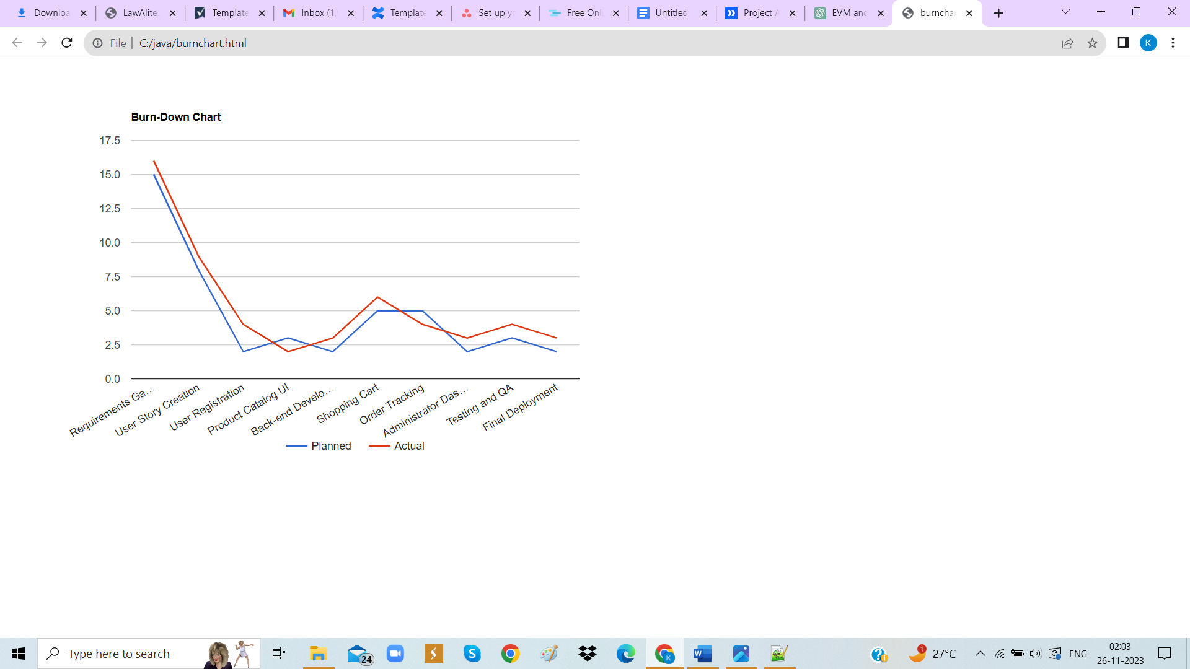

**6. PROPOSED ENHANCEMENT**

* User Reviews and Ratings
* Advanced Search and Filtering
* Personalized Recommendations

**7. CONCLUSION**

* The Online Footwear Shopping System project has successfully addressed the initial objectives and requirements, resulting in the creation of a functional and user-friendly platform for online footwear shopping.
* Throughout the project, we have maintained a strong focus on meeting the needs and expectations of our users. The system's features, search capabilities, and streamlined checkout process reflect this commitment to user satisfaction.
* The use of Agile methodologies allowed the project to adapt and evolve as market trends and user preferences changed. This flexibility ensured that the system remains relevant and competitive in the ever-evolving e-commerce landscape.
* We recognize that the journey does not end with the project's completion. To stay ahead in the dynamic e-commerce market, we are committed to ongoing improvements and enhancements, such as the addition of user reviews and personalized recommendations.
* Security and reliability have been paramount throughout the project. We have implemented measures to protect user data and provide a seamless, secure shopping experience.

**8. BIBLIOGRAPHY**

* Amazon ([www.amazon.com](http://www.amazon.com))
* FlipKart ([www.flipkart.com](http://www.flipkart.com))
* Meesho ([www.meesho.com](http://www.meesho.com))